**DSA FINAL PROJECT REPORT**

**Building a Virtual Cybersecurity Laboratory and Conducting Android Forensics Investigations**

Olora Olatunji David

Digital Skillup Africa

7/3/2025

**PROJECT PART I**

**Virtual Cybersecurity Lab Setup**

**Objectives:** To simulate a secure, real-world environment for offensive and defensive security testing through

virtual machines.

**Tools used:**

* Oracle VirtualBox
* Kali Linux ISO
* Windows 10 ISO
* Host Machine: Acer, 8 GB RAM, Windows 11, 64-bit operating system, Intel Core i5 2.20GHz dual core

**Virtual Machines Setup**

* Kali Linux (Attacker)
* Windows 10 (Target)

**Network Configuration**

* Network Type: Bridged Adapter
* Inbuilt Nmap Kali Tool
* Kali IP: 192.168.0.174
* Windows IP: 192.168.0.161

**Verifying Connectivity through Ping Test**

* Ping test from Kali ---- Windows
* Ping test from Windows ---- Kali

These were tested using commands on both VMs:

**ip a** on Kali - provides Kali Linux IP address

**ipconfig** on Windows – provides Windows 10 IP address

*Faced an issue where Kali couldn’t ping Windows. This was caused by interference from Windows firewalls. In this case, Inbound rules were set on Windows to allow ICMPv4. This allows Kali to ping Windows.

**Service Enumeration through Nmap scan on Kali**

During the lab, three key nmap commands were executed from Kali Linux to the Windows 10 VM to simulate active service discovery and enumeration.

1. **Nmap -Sv 192.168.0.161** - This command performs a TCP SYN scan and attempts to identify the version of the services running on open ports using the -sV flag (Service Version Detection).

What it discovered:

* Detected port 5357/tcp as open
* Identified service: Microsoft HTTPAPI httpd 2.0. This service is part of Windows' SSDP/UPnP system
* Other ports were filtered or blocked (likely due to the Windows Firewall)

1. **Nmap -sC 192.168.0.161** - This command runs Nmap’s default script set (-sC) in combination with service version detection (-sV). These scripts perform common enumeration tasks like: Checking HTTP servers, inspecting SMB shares, and Banner grabbing

What it discovered:

* Same open port 5357/tcp confirmed
* Returned additional HTTP headers: Microsoft-HTTPAPI/2.0
* Helped validate that the service is an embedded web component of Windows

This is a deeper scan that simulates what a real attacker might do to extract more service info.

1. **Sudo nmap -O 192.168.0.161**: The -O option attempts to detect the operating system by analysing TCP/IP fingerprinting (packet responses, TTLs, window sizes, etc.)

What it discovered:

* OS detected: Microsoft Windows 10
* Confidence levels: 91–97%
* Network distance: 1 hop (proves they’re on the same local network)

OS detection is useful for attackers to tailor exploits or for defenders to verify system exposure.

**Creating Shared Directories**

A shared folder was created on Kali Linux and made accessible to the Windows 10 VM via SMB protocol using Samba. This simulates an internal file sharing scenario and demonstrates basic post-exploitation data movement capability.

**Steps:**

* Shared folder /home/kali/sharefolder was created
* Samba is configured with read-write access
* Accessed the folder and its contents via Windows VM

**Screenshots of Important Procedures and Processes for Part 1:**

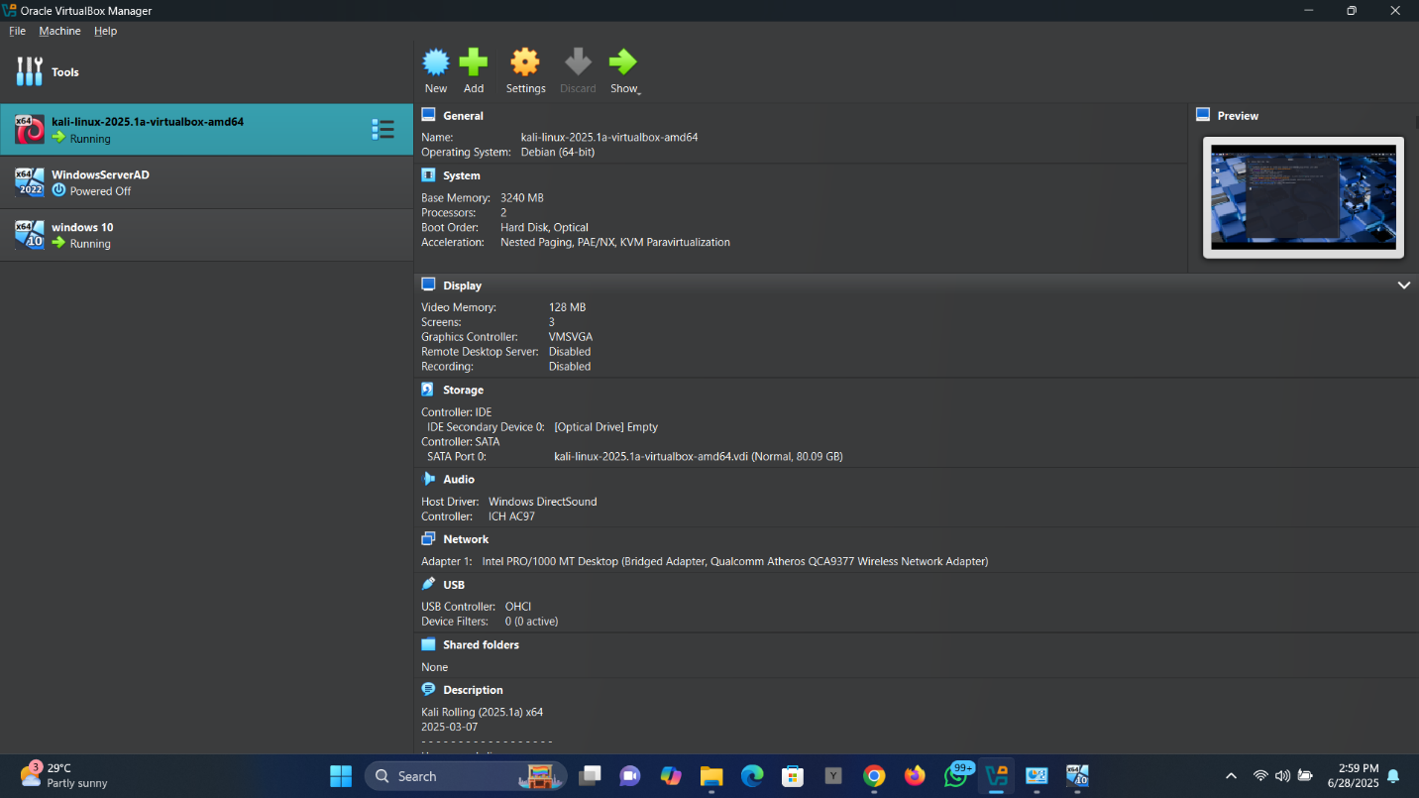

Virtual lab created and running on the host pc

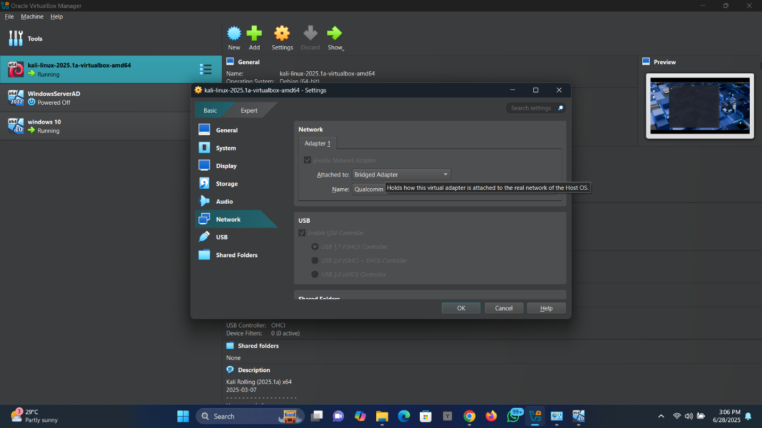

Setting up a virtual lab environment and configuring network adapters to allow connectivity between devices

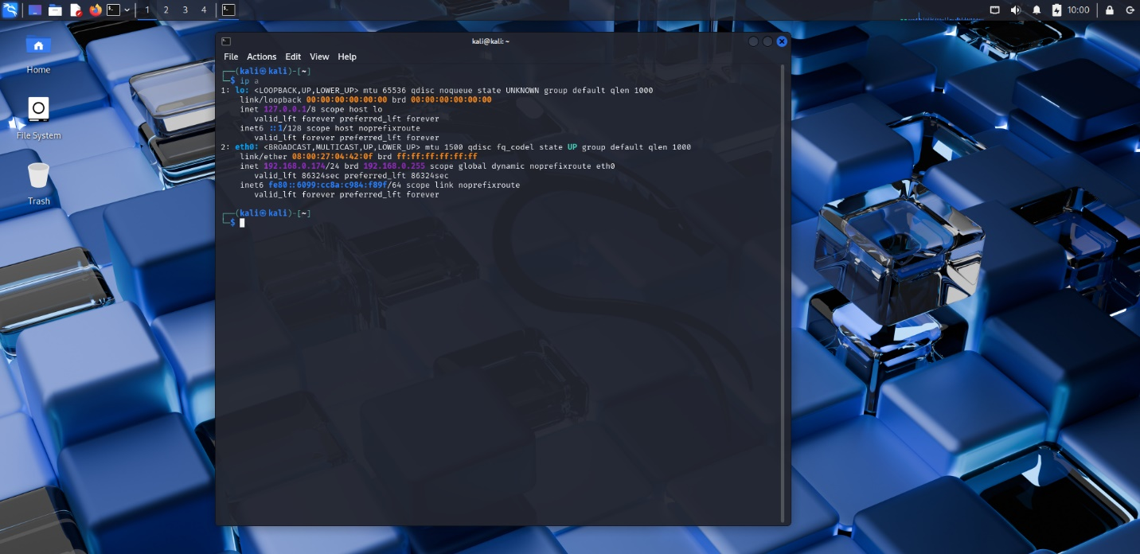

IP a in kali to determine ip address

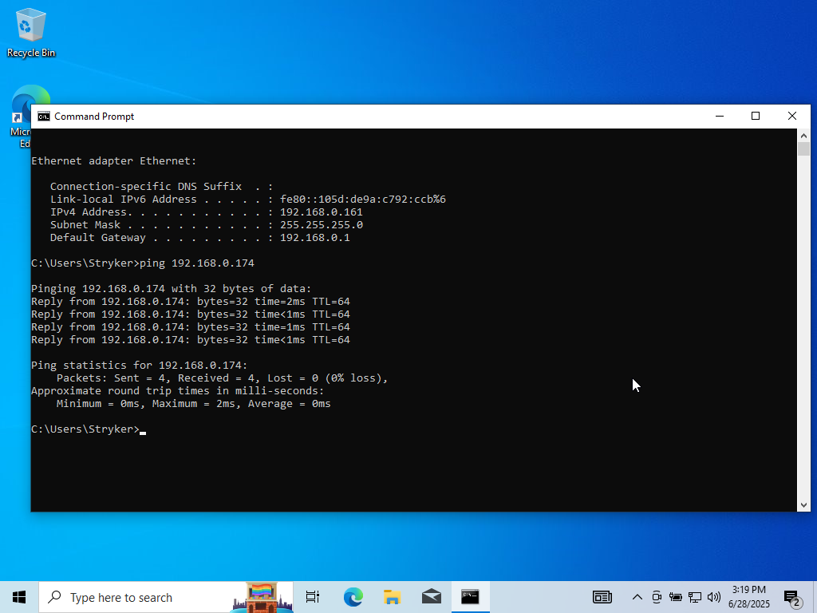ipconfig in Windows to determine ip address

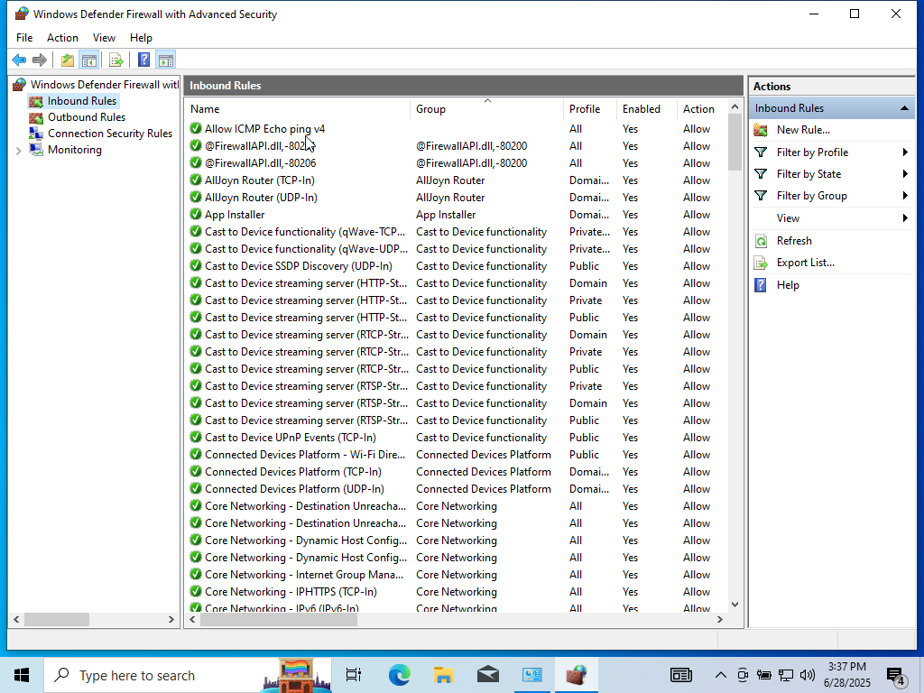Inbound rules set on Windows to allow incoming pings from Kali

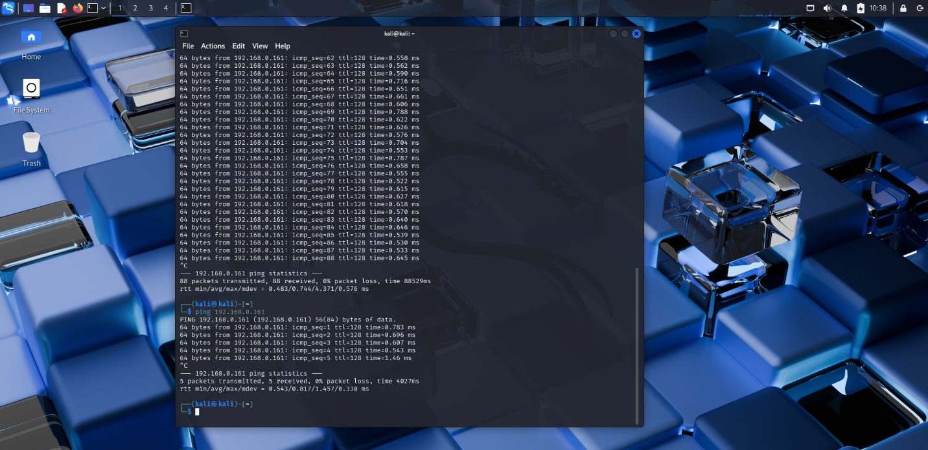



Ping success from both VMs

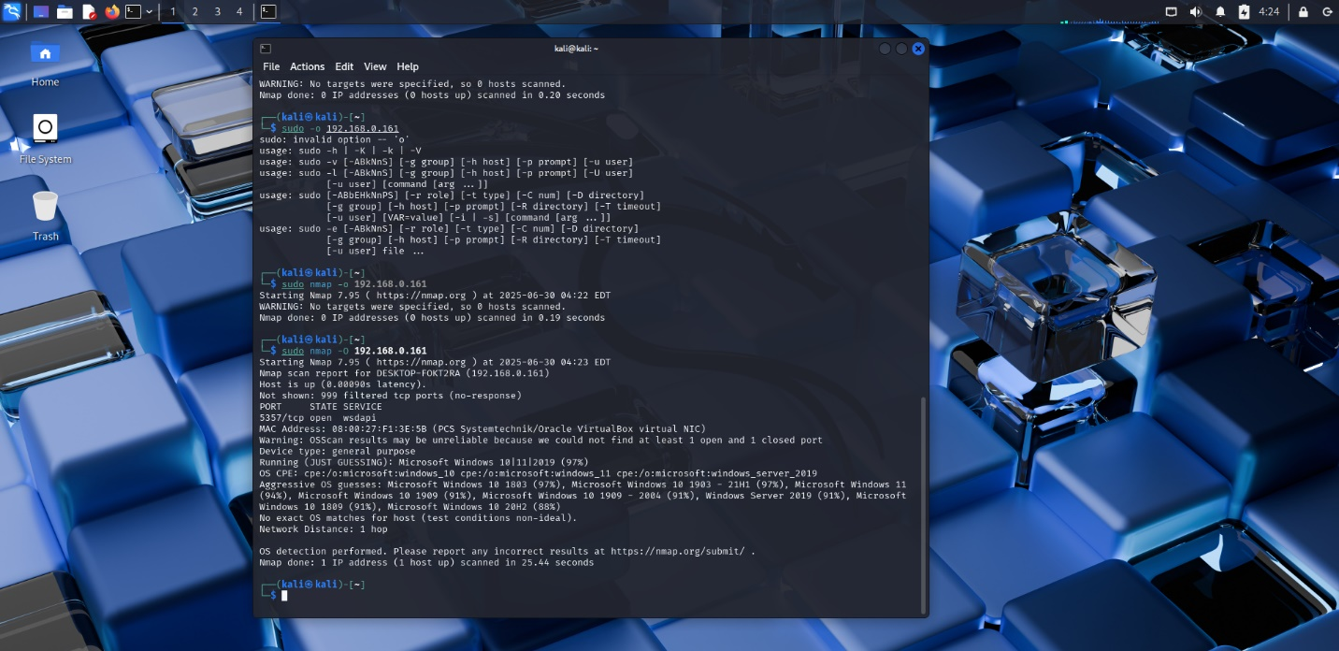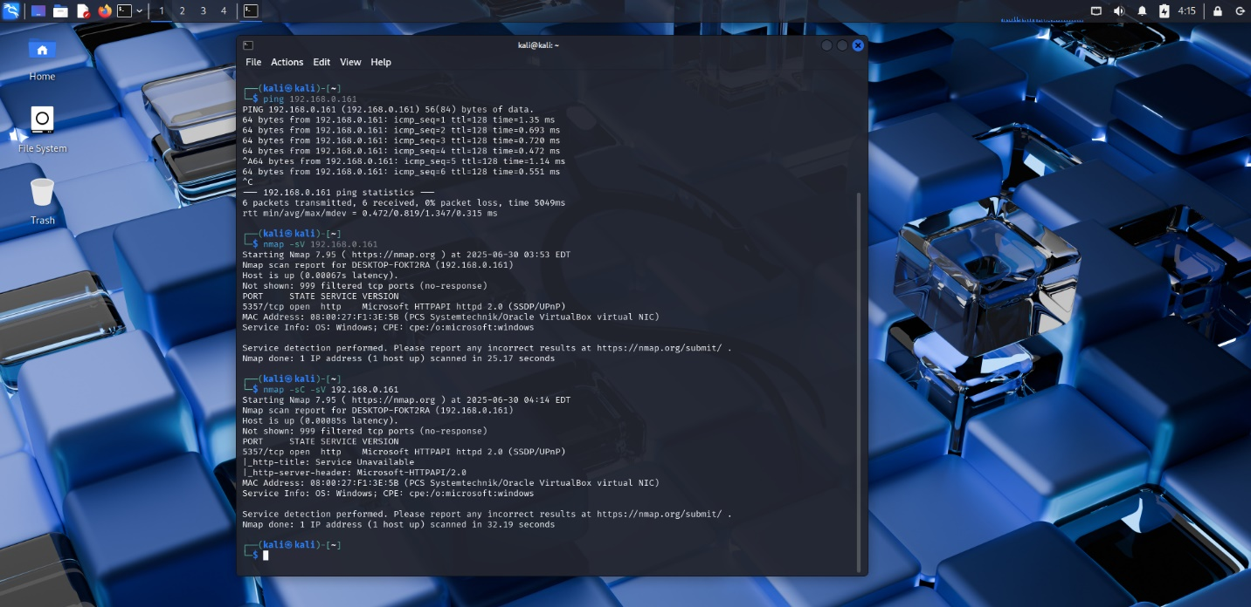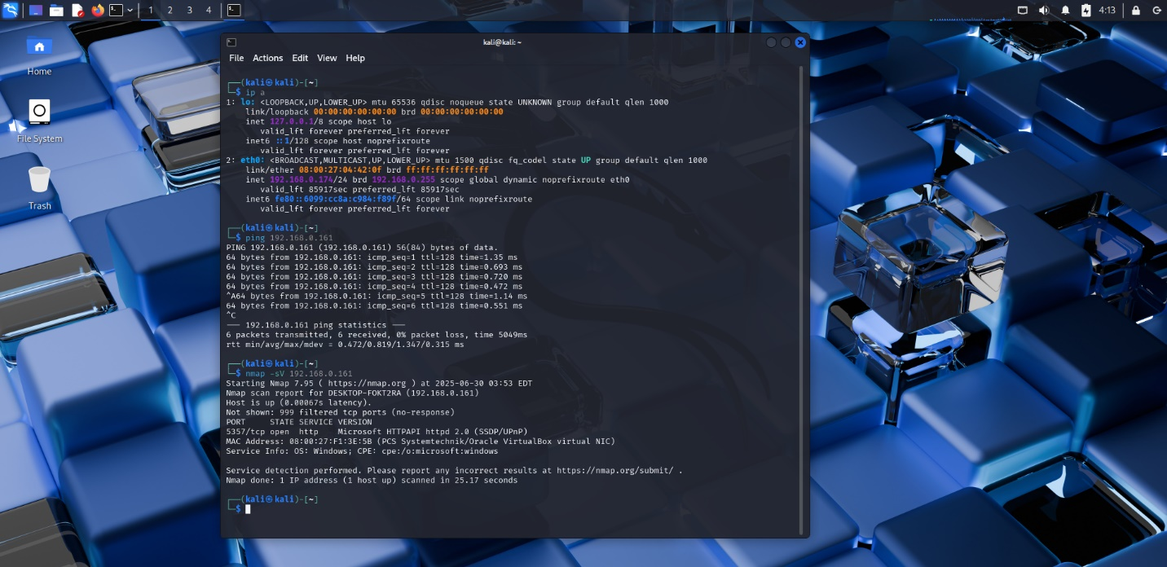Nmap scan from Kali to Windows IP

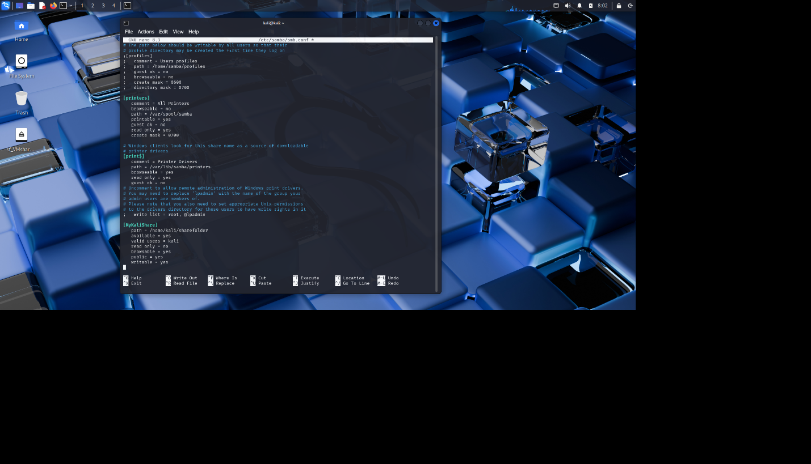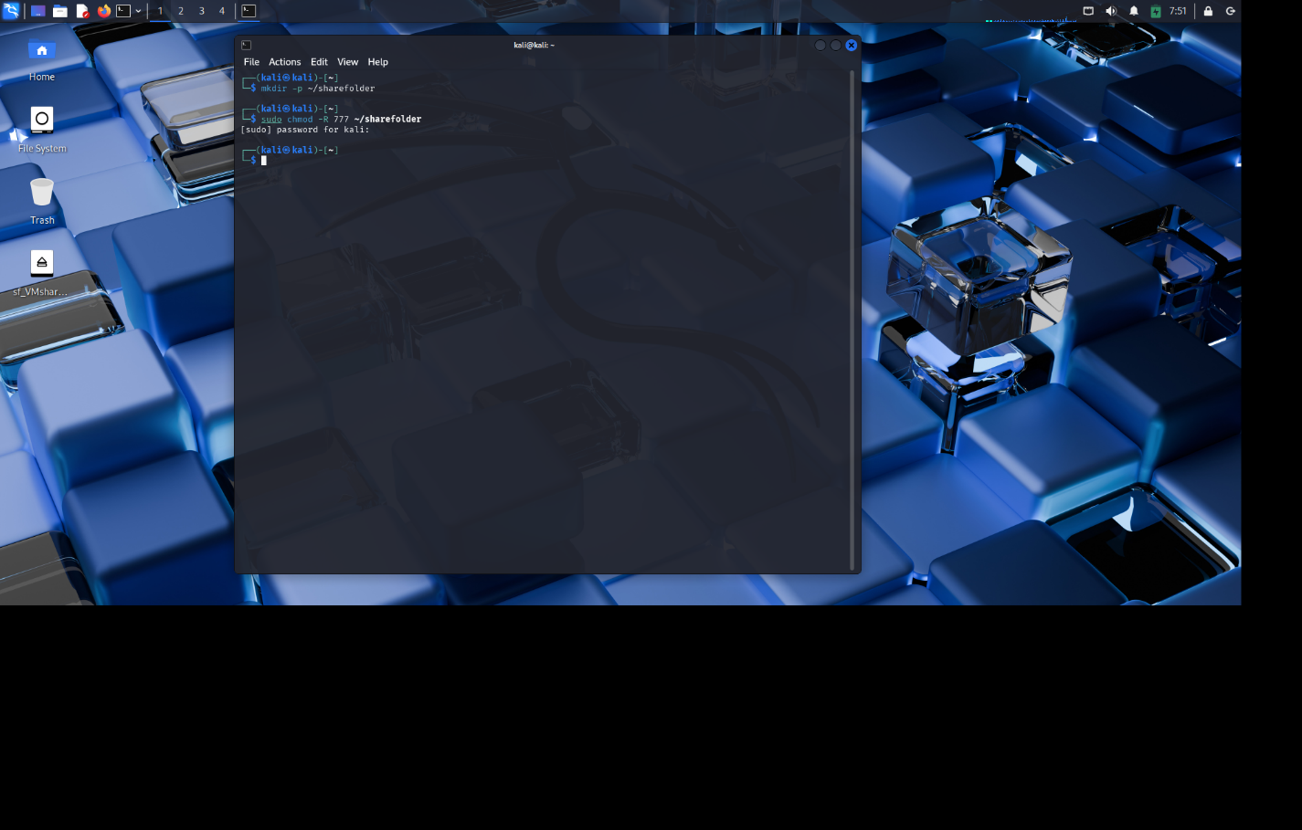

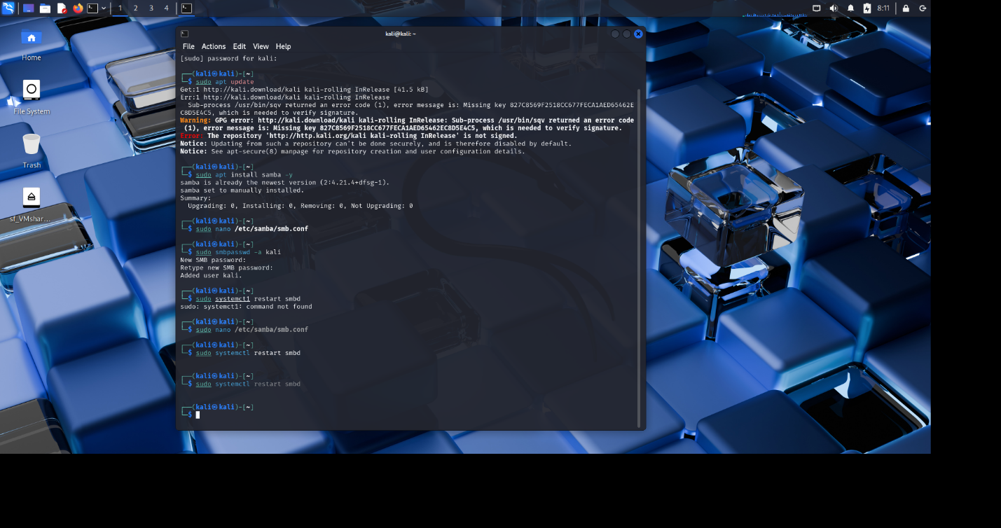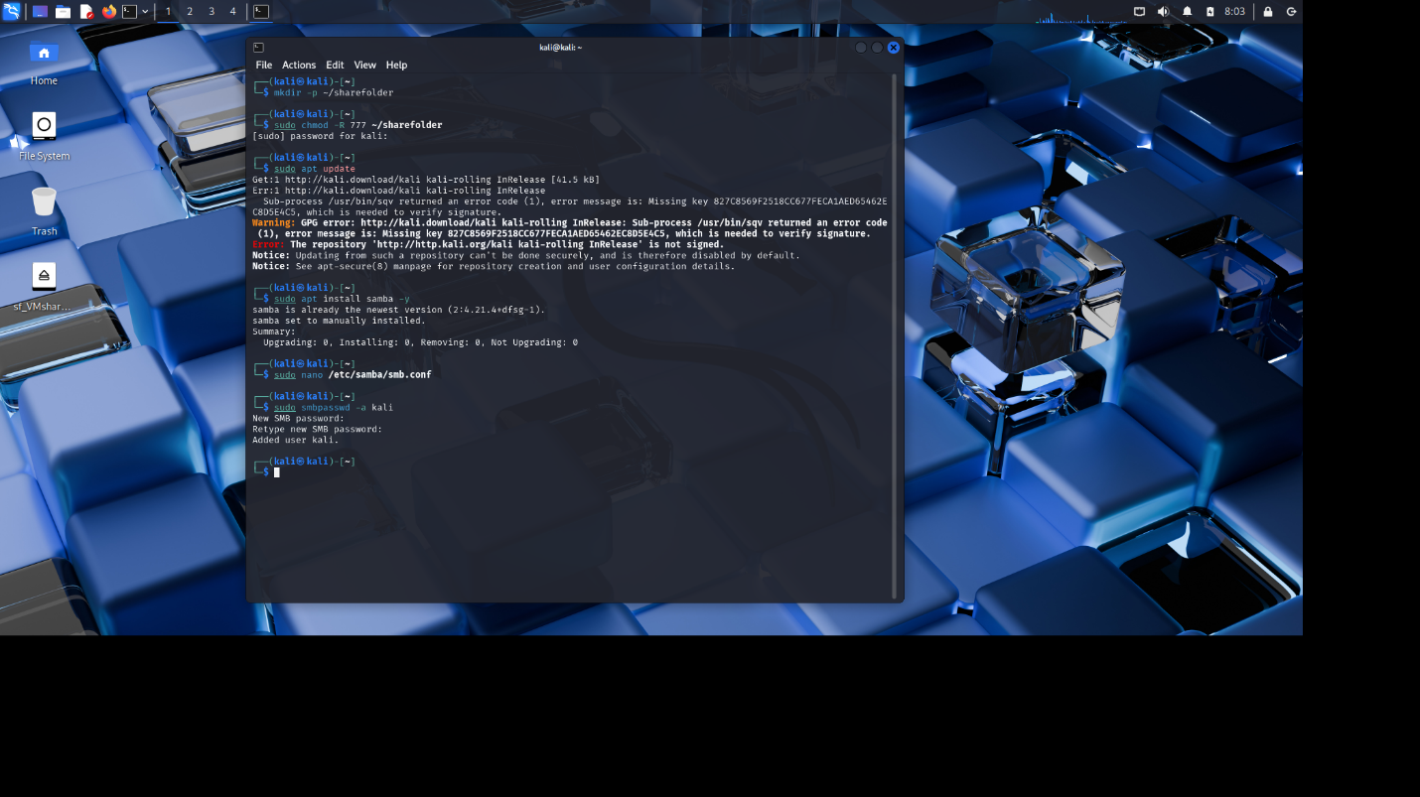

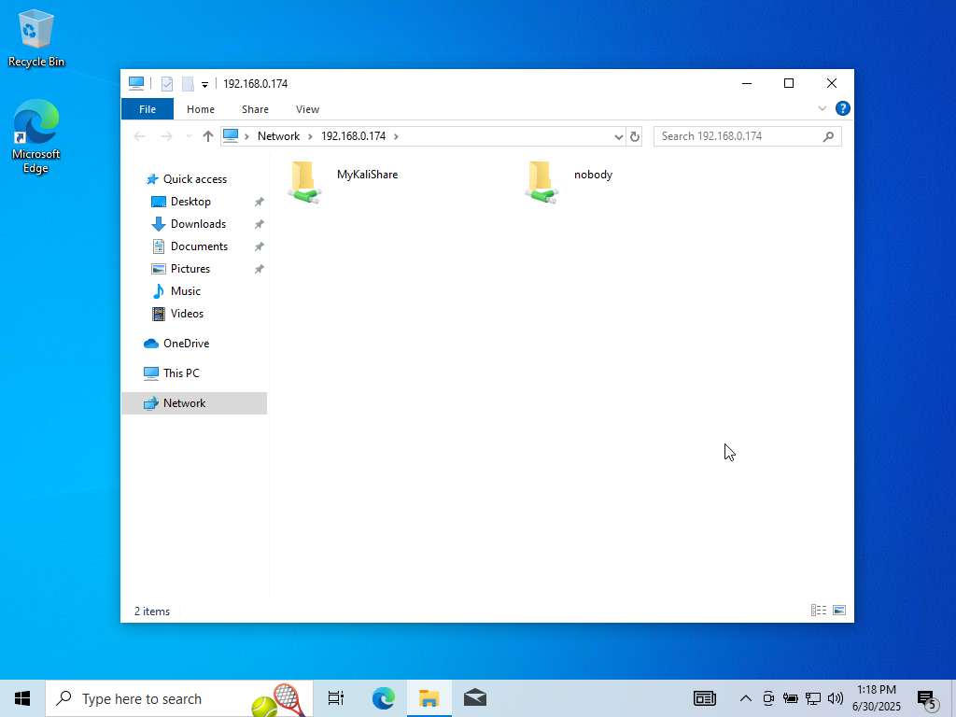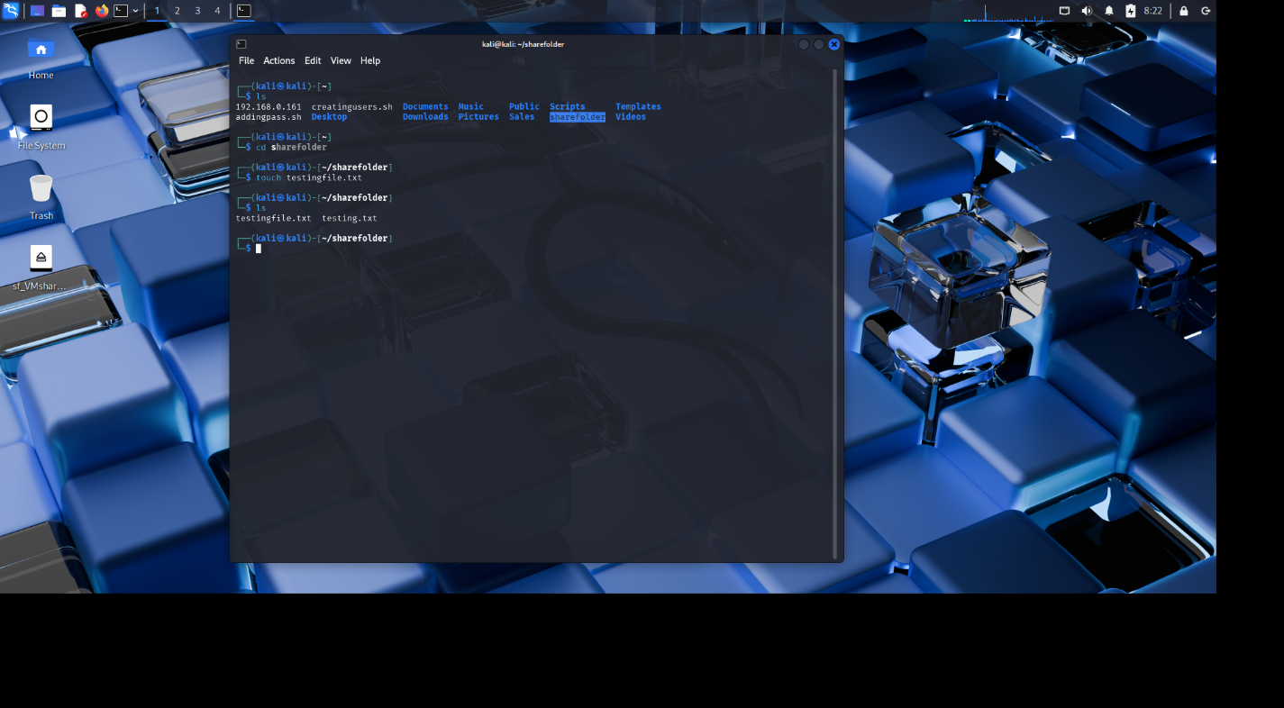Images showing the processes involved in creating a public directory and Samba setup

And also showing the transferred files visible on both systems

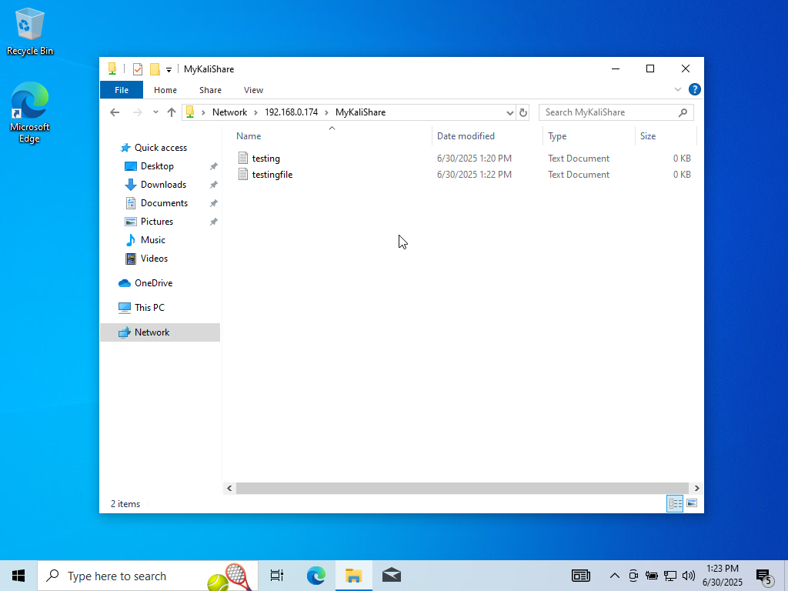Files successfully accessed on Windows 10 VM

**PROJECT PART II**

**Android Forensics Investigation Report -**

Case Title: Android Image Analysis – Case 001

Analyst: Olora Olatunji David

Date of Analysis: 30 June 2025

Tool Used: Autopsy (version 4.22.1)

Image Type: .tar extracted logical image

**Objective:** To analyse a provided Android forensic image and compile a formal digital investigation report.

**Tools and Setup:**

* Image File: android_image.tar (provided)
* 7-Zip file extractor
* Analysis Tool: Autopsy (Version 4.22.1)
* System: Host PC running Windows 11
* Method: Logical files added to a new Autopsy case

**Methodology**

* The .tar file was extracted using 7-Zip.
* The extracted folder was loaded into Autopsy using the Add Logical Files option.
* The following ingest modules were enabled:
  1. File Type Identification
  2. Android Analyzer
  3. Keyword Search
  4. Recent Activity
  5. File Type Identification
* Each module generated categorised evidence in the left-hand tree view.

**Key Findings**

|  |  |
| --- | --- |
| **CATEGORY** | **Items Found** |
| 1. Call Logs | 14 entries |
| 1. Communications Accounts | 3 accounts (credit card, device and phone) |
| 1. Contacts | 7 contacts |
| 1. Installed Programs | 5 installed programs |
| 1. Messages | 28 messages |
| 1. Metadata | 3 metadata |
| 1. Web Cookies | 207 web cookies |
| 1. Web History | 12 web histories |
| 1. Web Search | 4 entries |
| 1. Keyword Hits | 15,874 keyword hits |

**Analysis of Extracted Data**

The Android image provided for forensic analysis revealed multiple categories of digital artifacts that contributed to the reconstruction of the suspect's mobile activity. Notably, while some data such as application usage and deleted files were absent, the available artifacts offered significant insights into potentially fraudulent activities. During the examination of the recovered messages, several casual conversations with the suspect’s contacts (including a girlfriend and a religious leader) were observed. However, more critical messages suggested involvement in fraudulent schemes. Among the 28 recovered SMS messages, two primary threads were identified as containing suspicious and potentially incriminating content.

**Suspicious Activity Identified:**

**Message Thread 1**: Communication with "WoodBerry" (08032111133)

* Date of Interaction: 17 March 2024
* Time Window: 04:19:10 – 04:29:53 WAT

Initial conversations appeared casual but quickly escalated into a detailed discussion involving a proposed online scam. The suspect received a message suggesting the creation of a fake investment website. In response, the suspect explicitly agreed (“he’s in”) and further discussed the plan to lure victims by offering a non-existent cryptocurrency promising high returns.

Key elements extracted:

* Language suggesting prior scams: e.g., “same bitcoin wallet as before”
* Wallet address shared: “16AtGJbaxL2kmzx4mW5ocpT2ysTWxmacWn”
* Meeting arranged over Google Meet, suggesting an organized and premeditated effort

Cross-referencing the sender’s phone number with the contacts list revealed the individual is saved under the alias "WoodBerry".

**Message Thread 2**: Communication with "Hush Puppi" (+971543777711)

* Date of Interaction: 17 March 2024
* Time Window: 05:26:00 – 05:49:17 WAT

This thread builds on the earlier conversation and suggests a collaborative scam involving multiple actors. The suspect informs the contact about a newly built website intended to defraud users by mimicking a legitimate investment platform. Notable characteristics of the scam include:

* Fake investment portfolios
* Fabricated testimonials
* Manipulated interface design to gain trust

The link to the scam site was shared:

“https://apyeth.gifts/”

A new Bitcoin wallet address was also provided for financial transactions:

“1K1KMHpynJHQRbhzKHyik6yaJuQYxSaZCm”

Further inspection of the contact list revealed the name "Hush Puppi", which matches the alias of a well-known cybercrime suspect associated with high-profile internet fraud cases globally.

**Supporting Evidence in Web Activity and Keyword Searches**

* Web History: Included multiple entries related to investment scams, reinforcing the narrative constructed from SMS content.
* Web Search Terms:
* “how to scam investors online”
* “new investment scam methods”
* “how to avoid EFCC arrest”

These search queries strongly indicate preparation and research into fraudulent activities, including attempts to evade law enforcement, namely the EFCC (Economic and Financial Crimes Commission) in Nigeria.

The combined evidence across messages, contact names, shared links, wallet addresses, and browser activity reveals:

1. A clear intent to commit fraud
2. A history of organized scam attempts
3. Association with known fraud-related aliases
4. Efforts to remain undetected by authorities

**Conclusion & Recommendations**

The digital evidence extracted from the Android image suggests that the suspect is involved in coordinated cryptocurrency investment scams. The conversations, wallet addresses, and fake website references confirm intentional fraud. Web search queries and contact profiles further implicate the suspect as an active cybercriminal.

**Recommendations:**

* Perform deeper analysis using tools like MobSF or ALEAPP for app-level insights
* Cross-reference recovered wallet addresses with crypto monitoring tools (e.g., Blockchain Explorer)
* Law enforcement may issue search warrants based on strong indicators of fraud present in this evidence

**Screenshots to Support the Case**

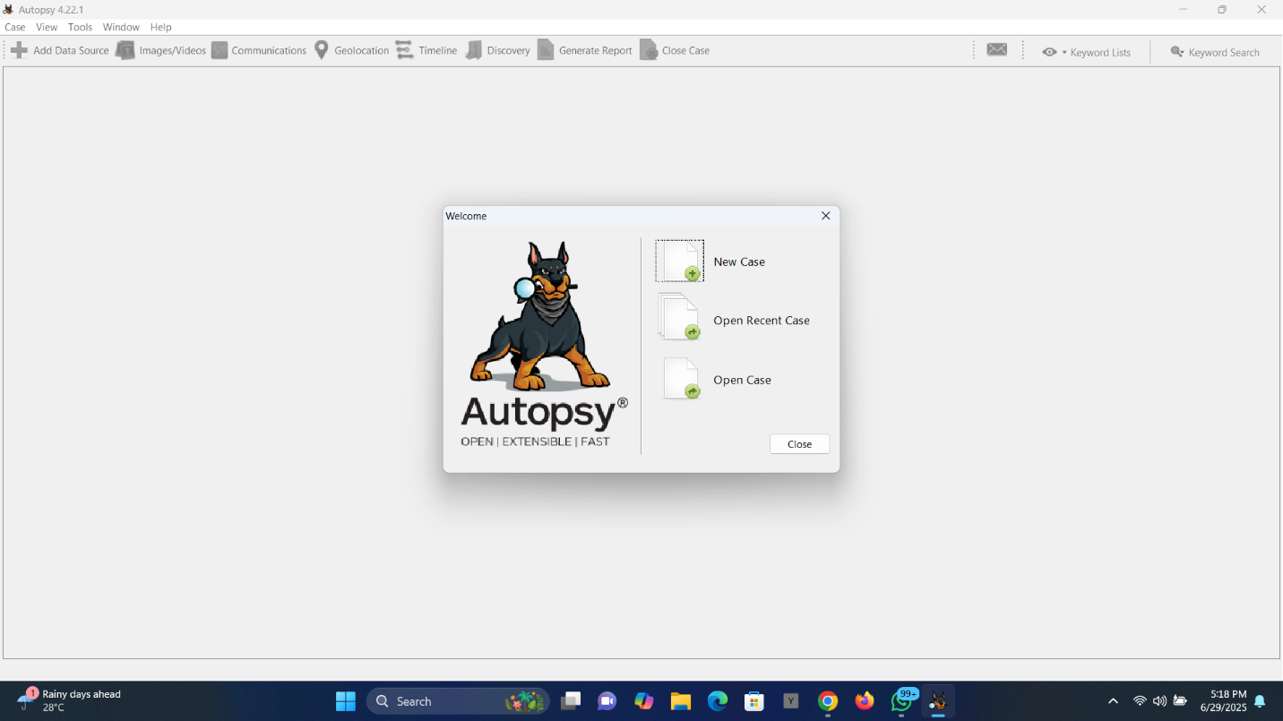Launching Autopsy and opening case 001

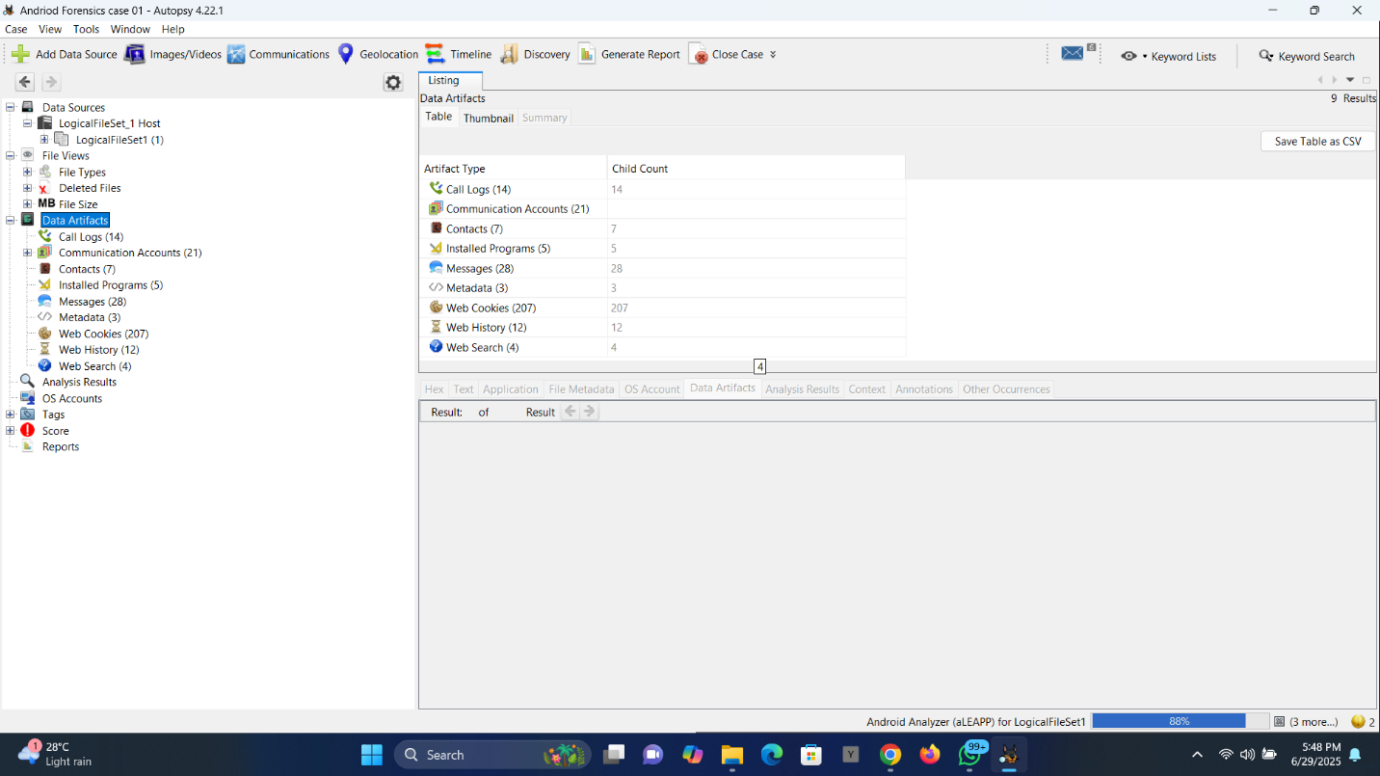Image showing a list of recovered artifacts

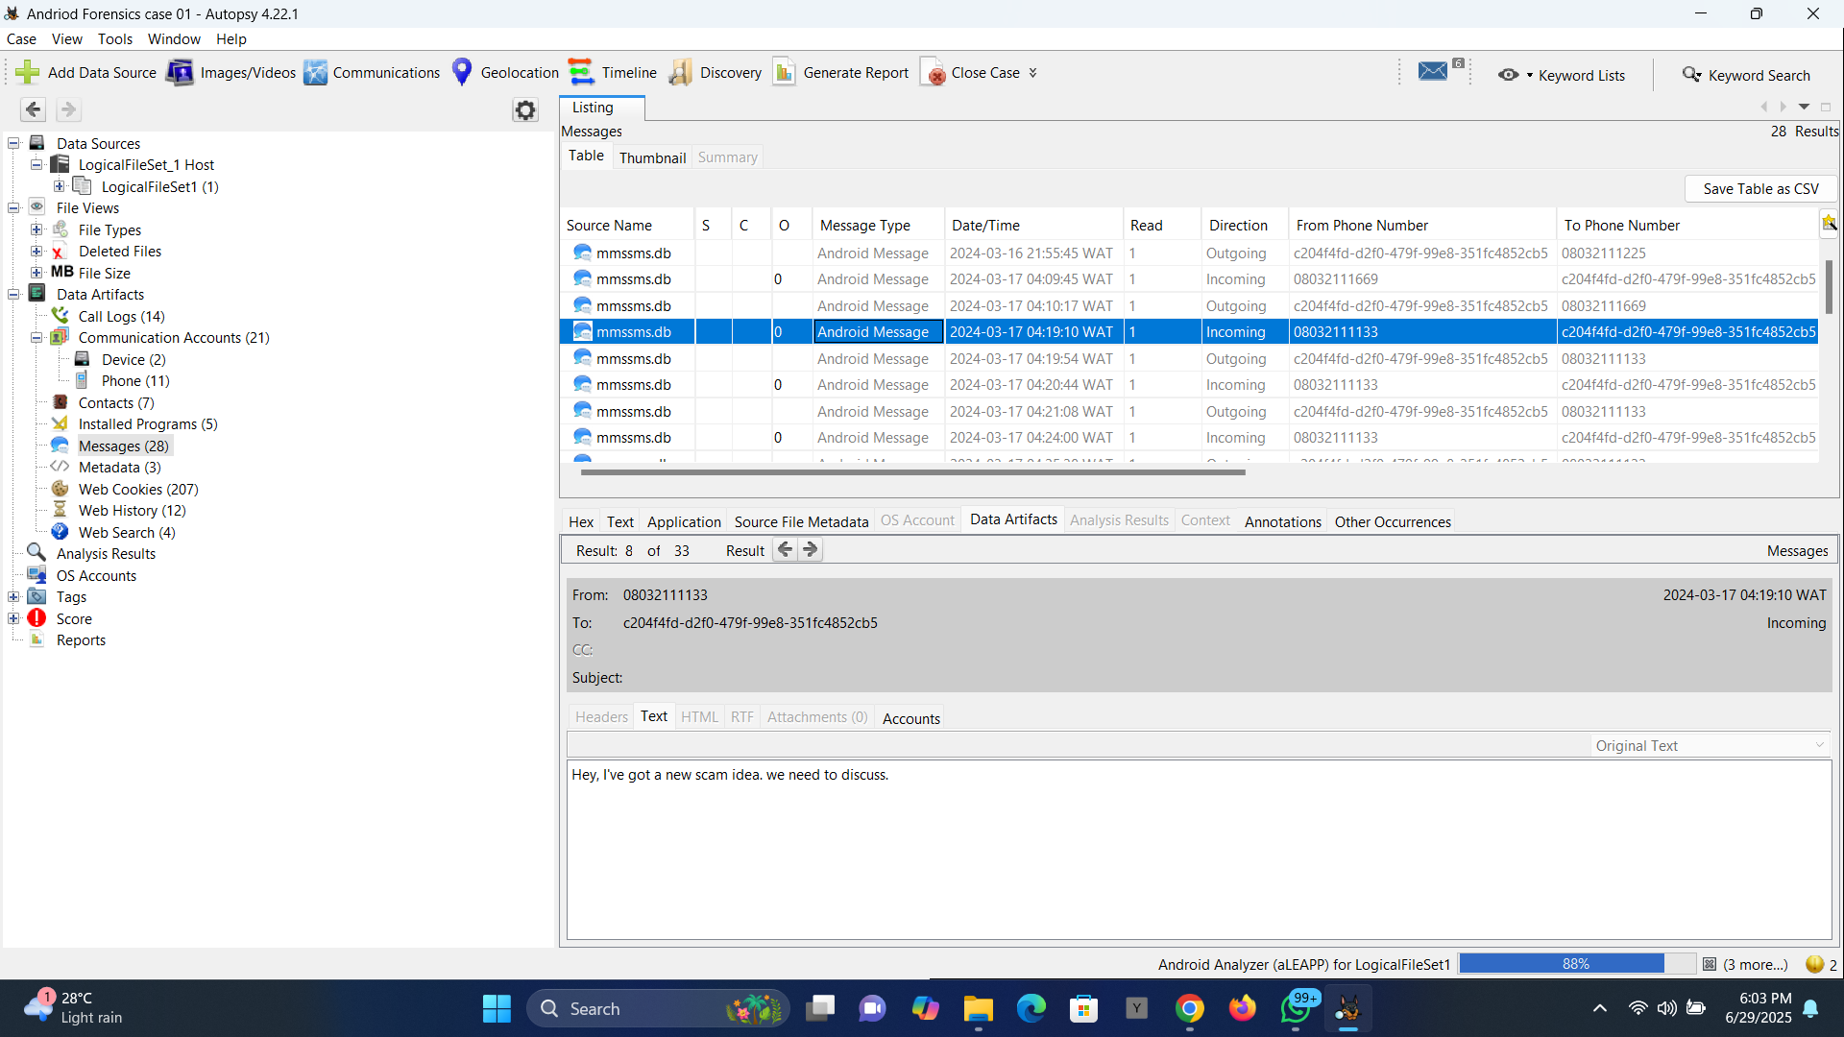

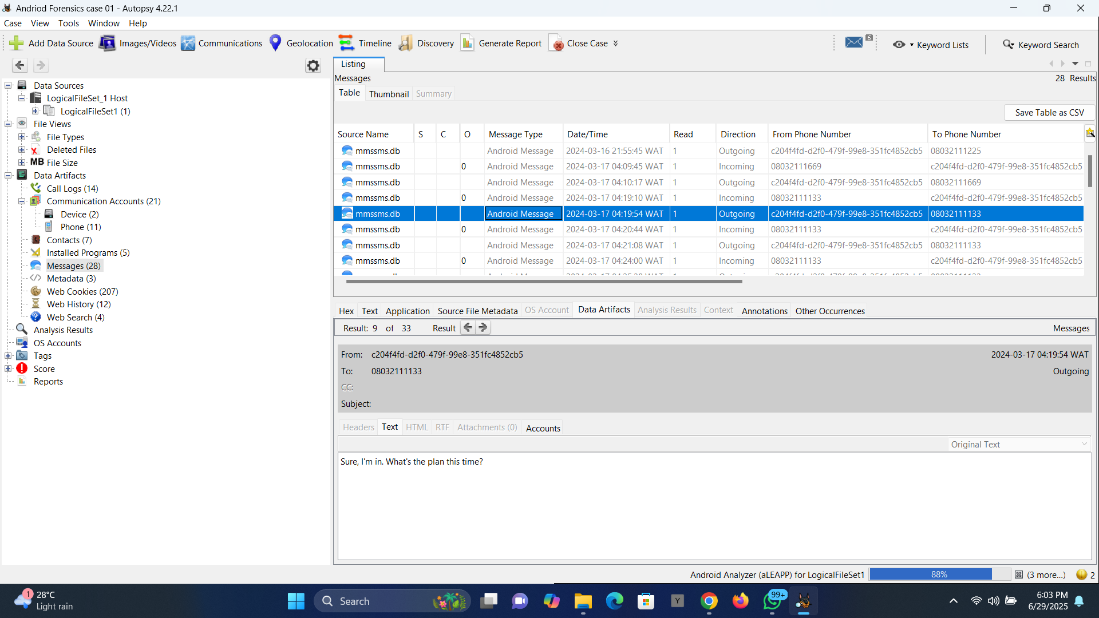

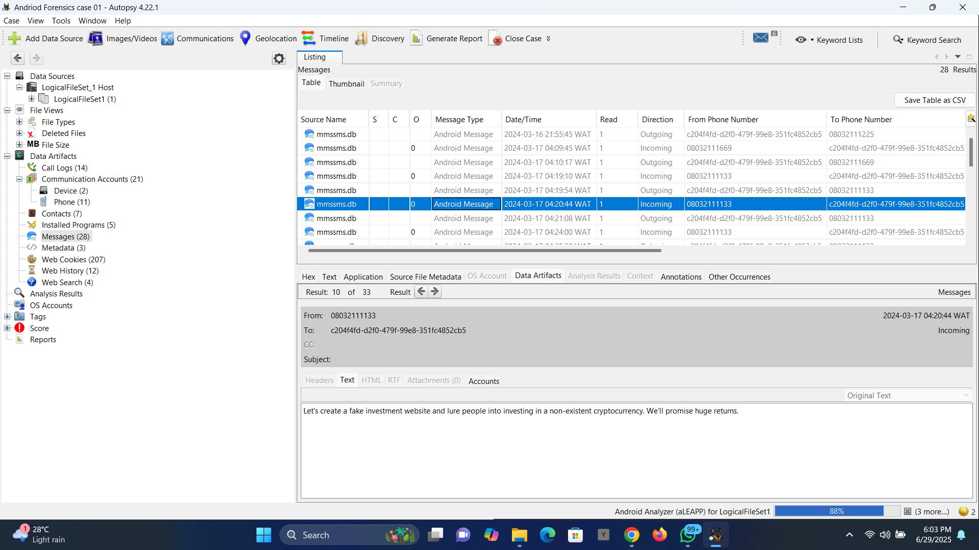

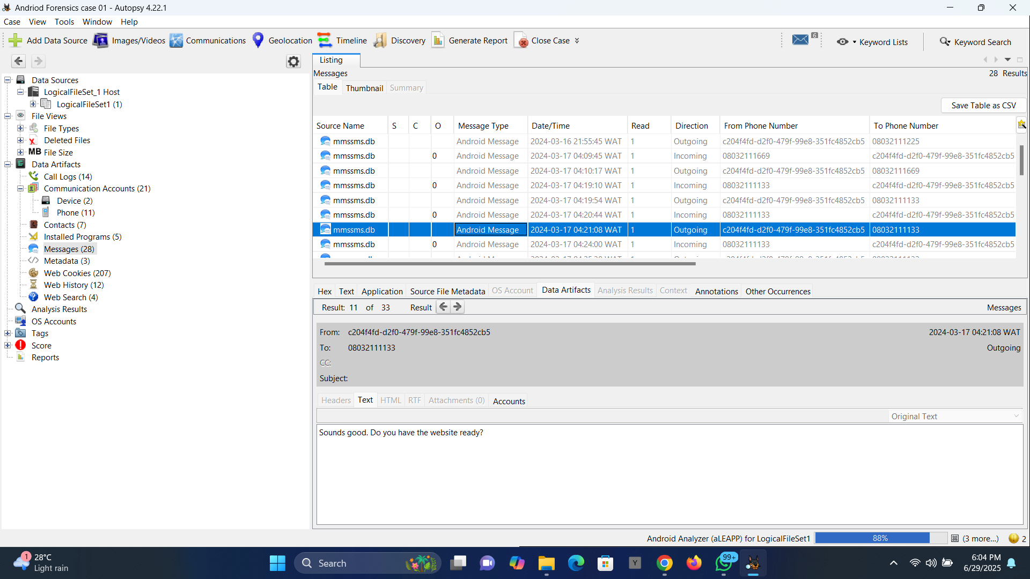

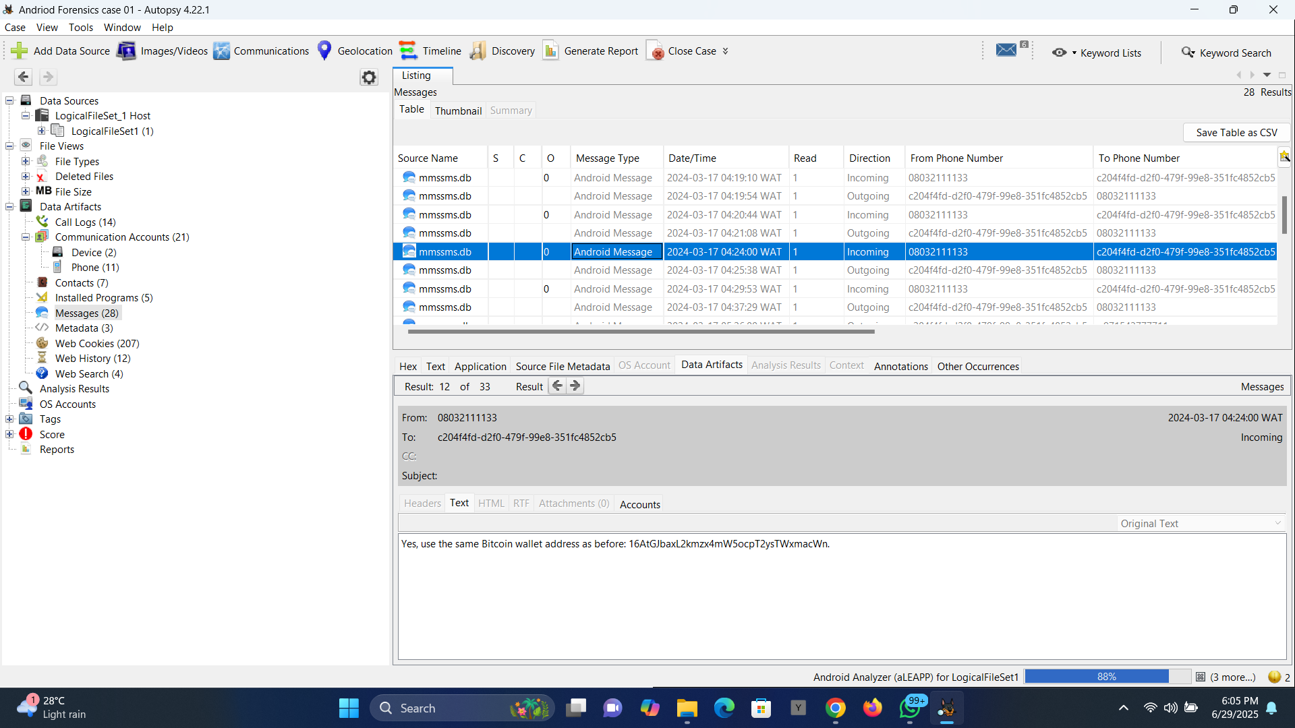

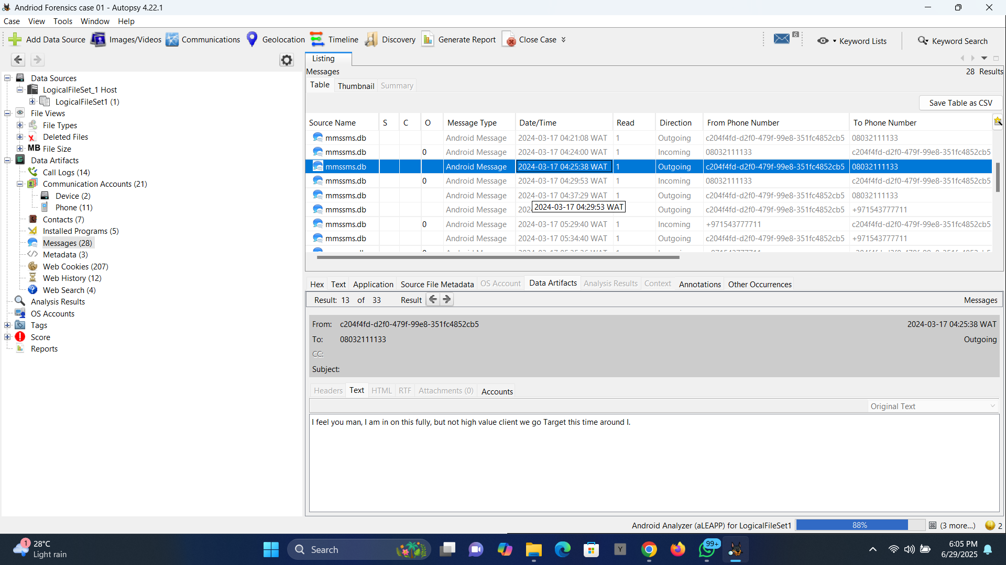

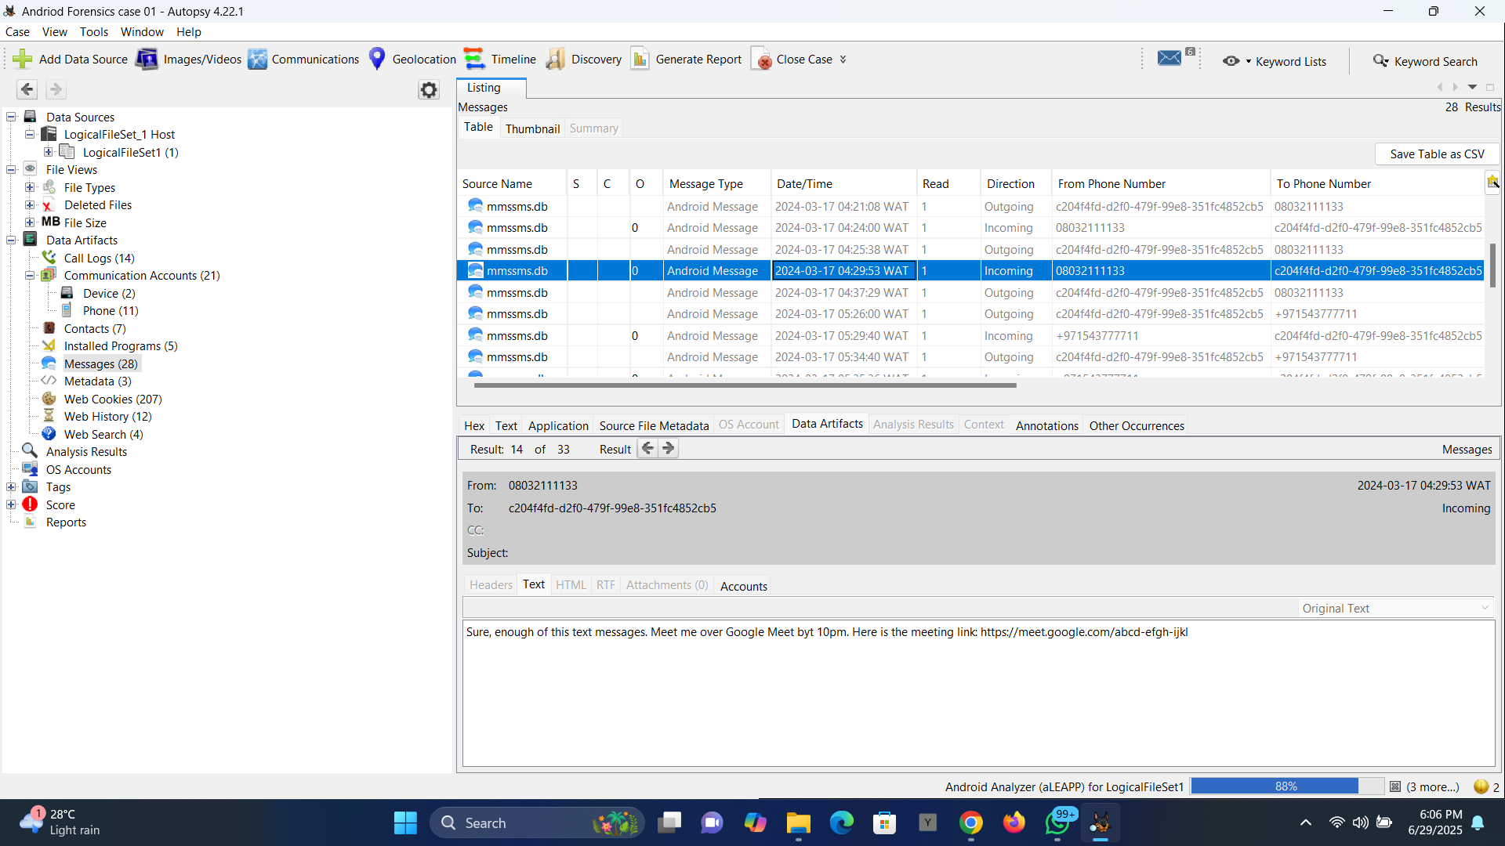

Images showing the suspect discussing a scam idea with a phone no 08032111133 named WoodBerry.

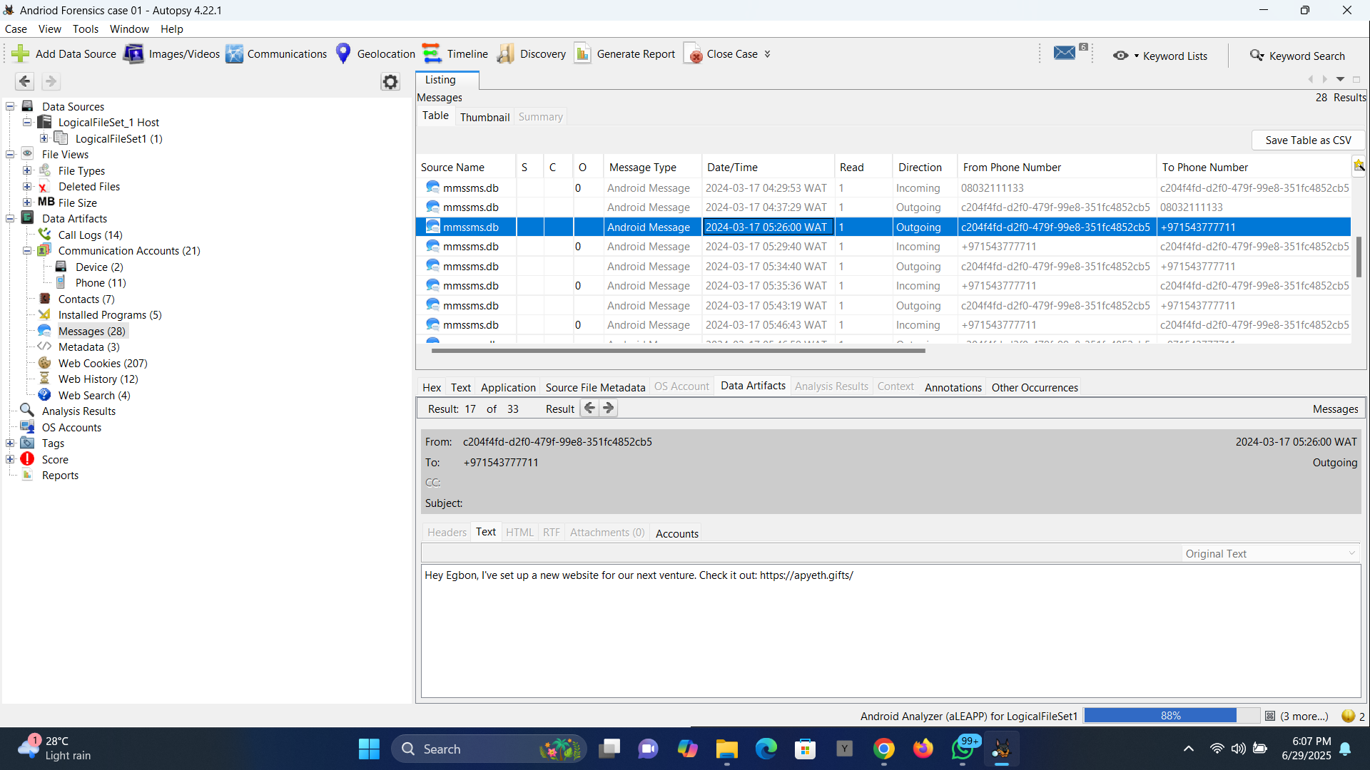

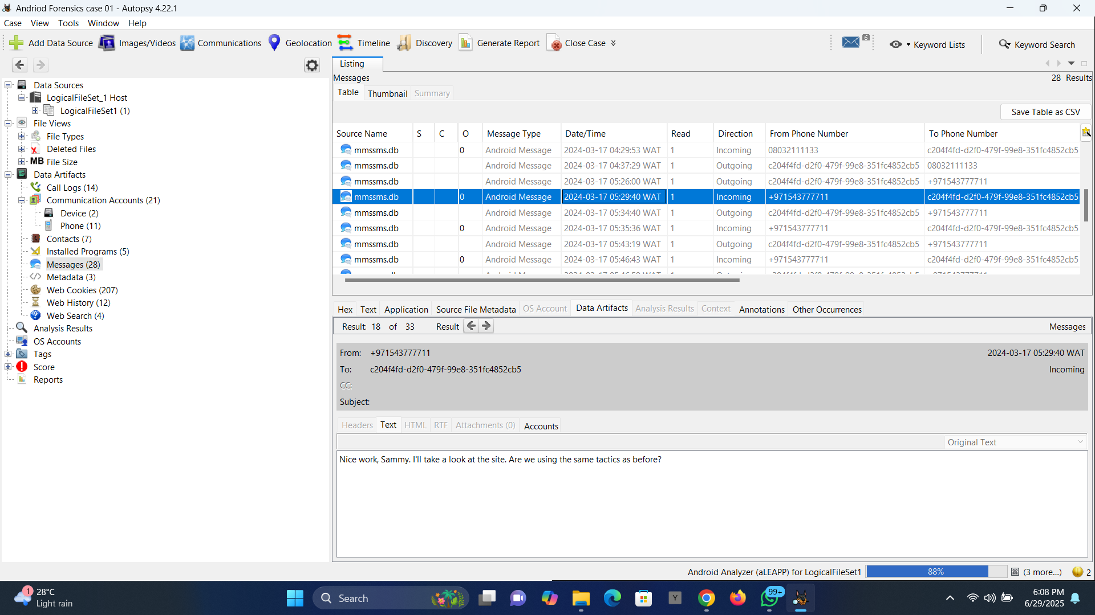

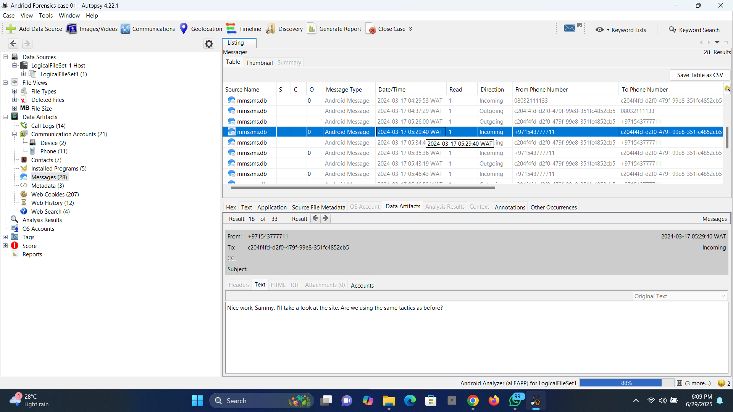

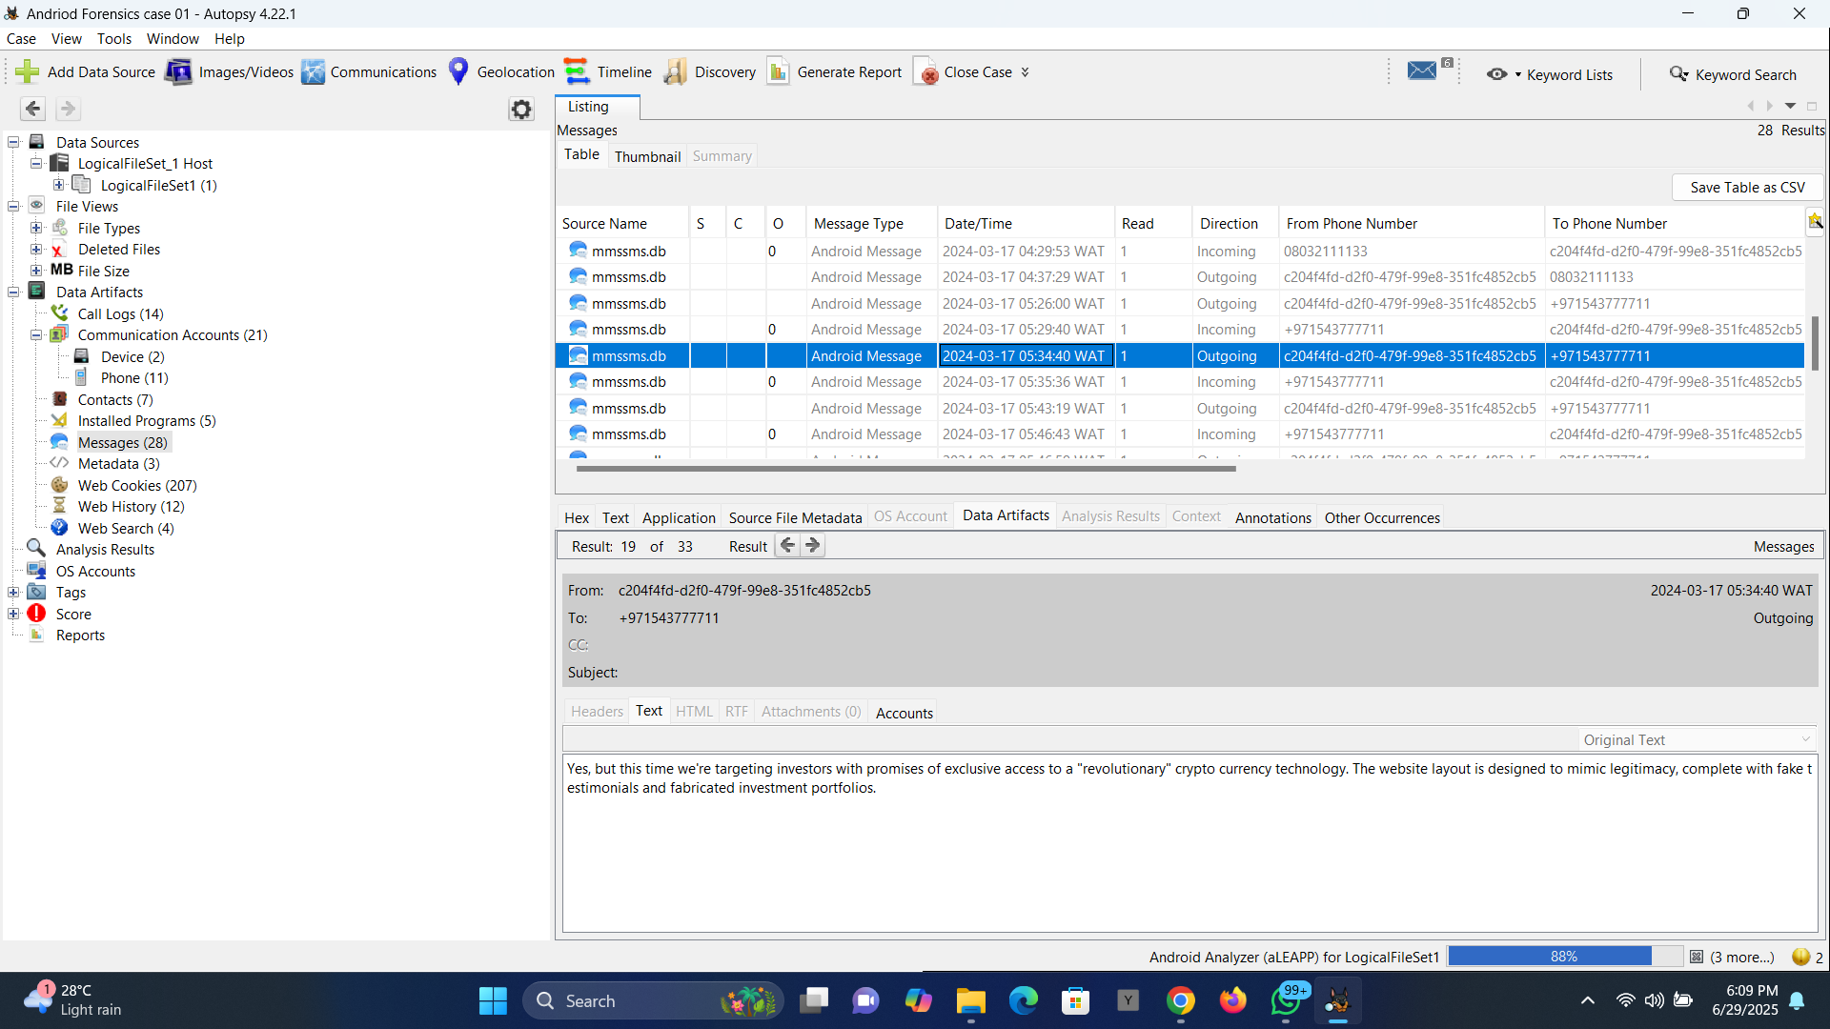

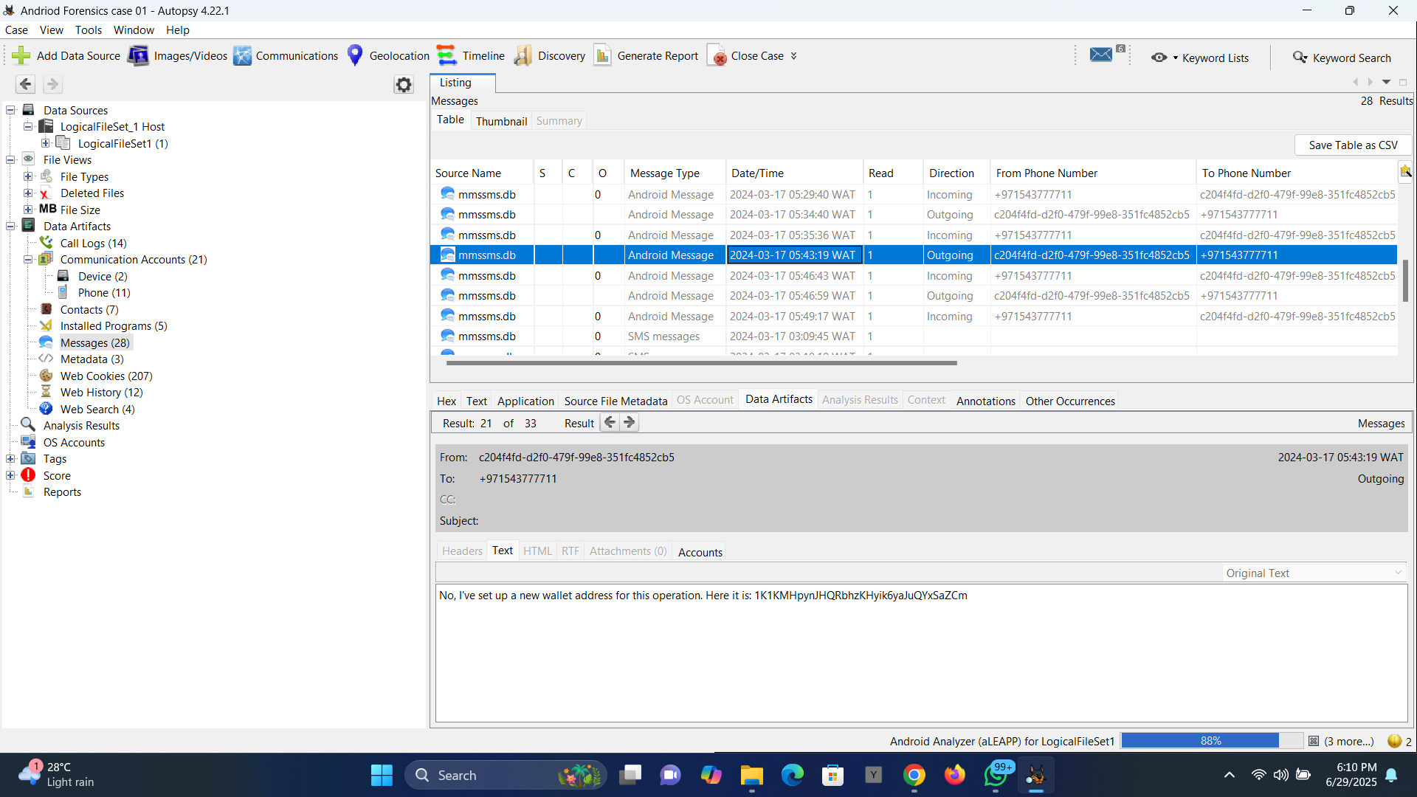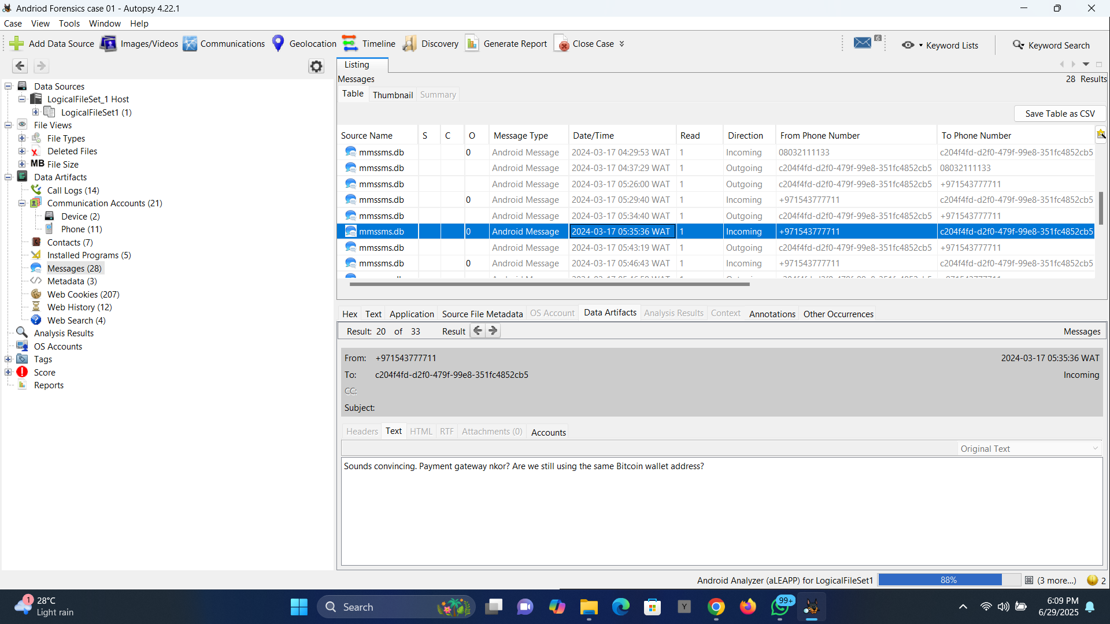



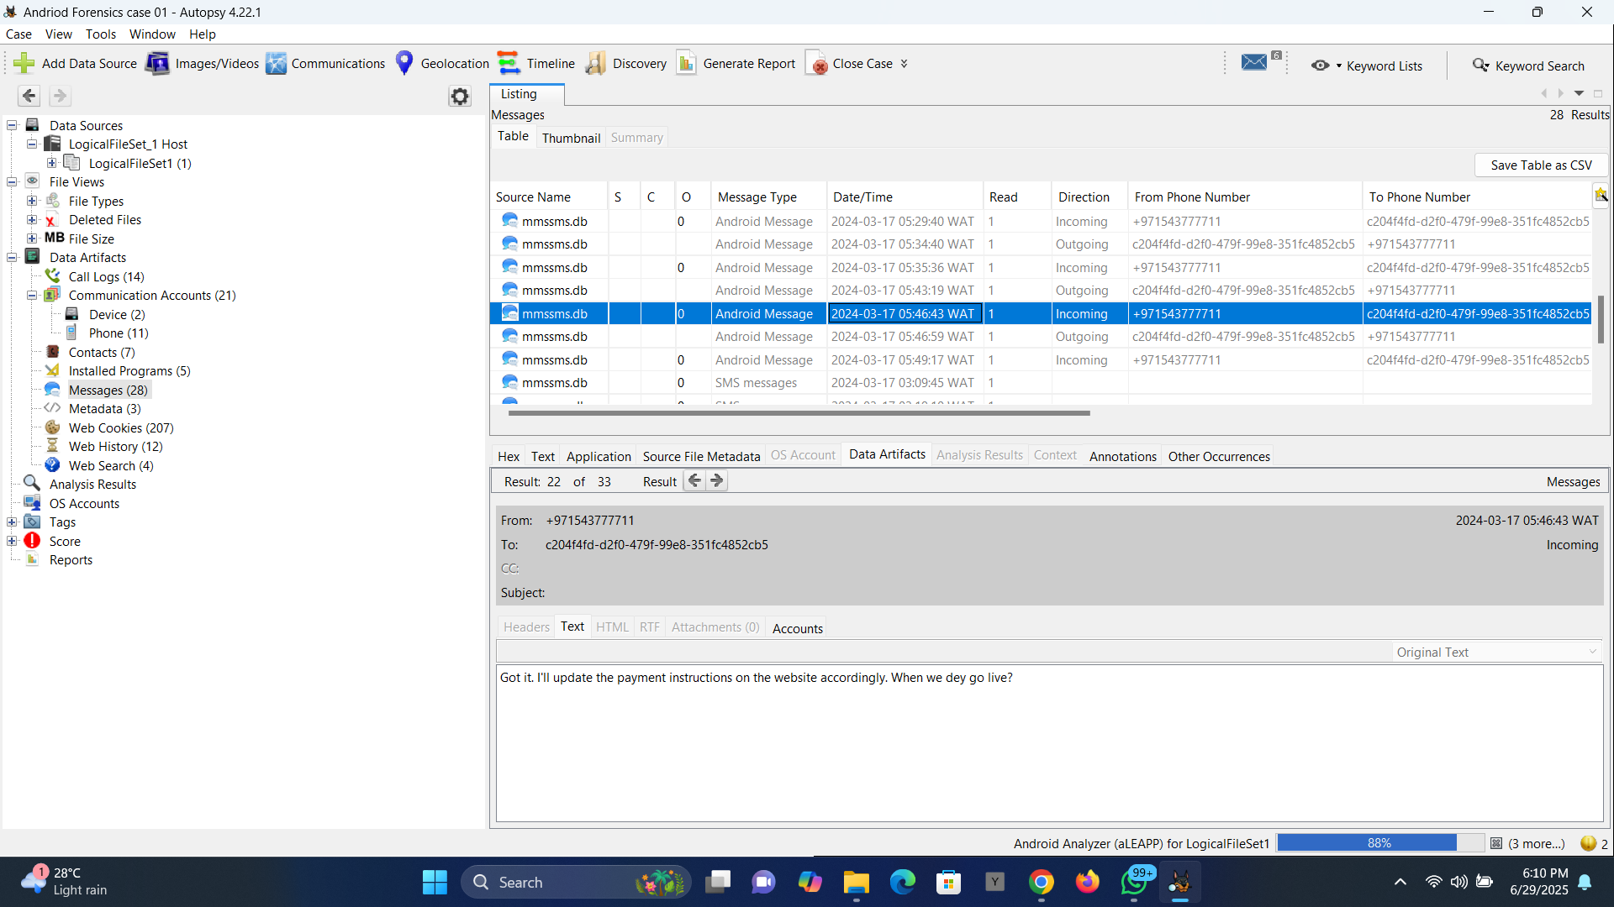

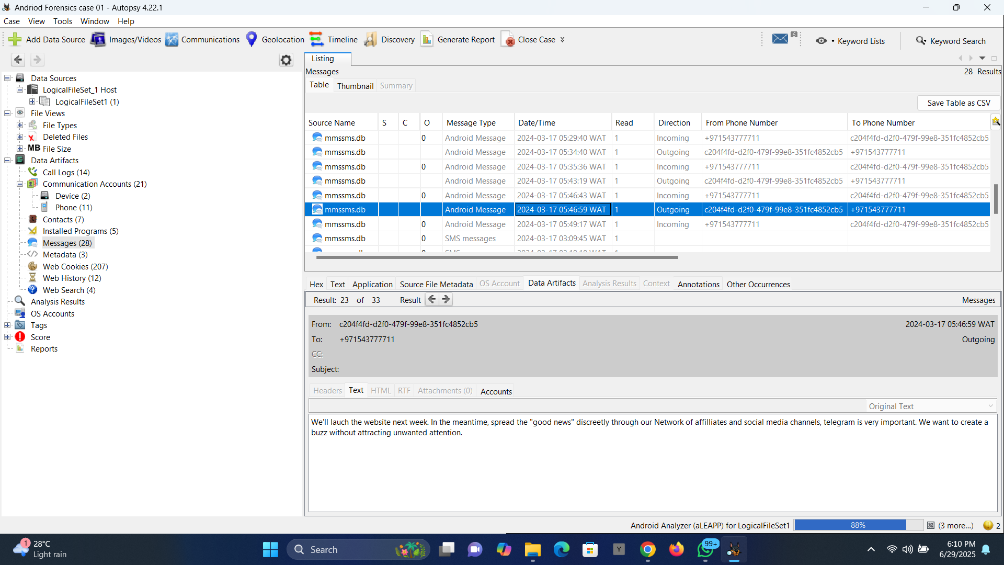

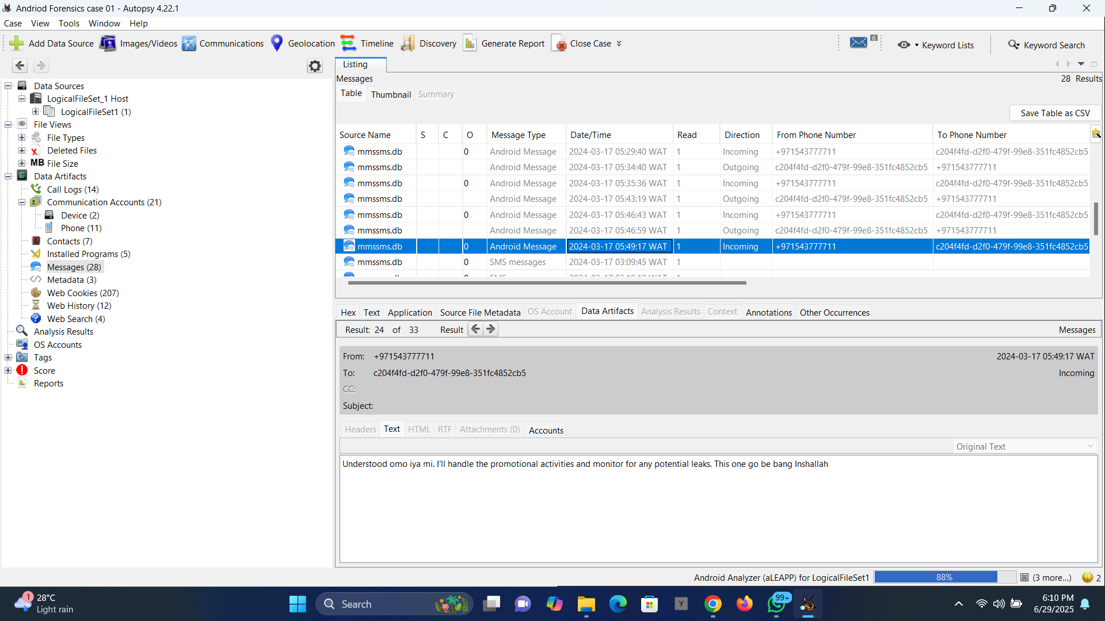

Second conversation with phone no +971543777711 saved as Hush Puppi

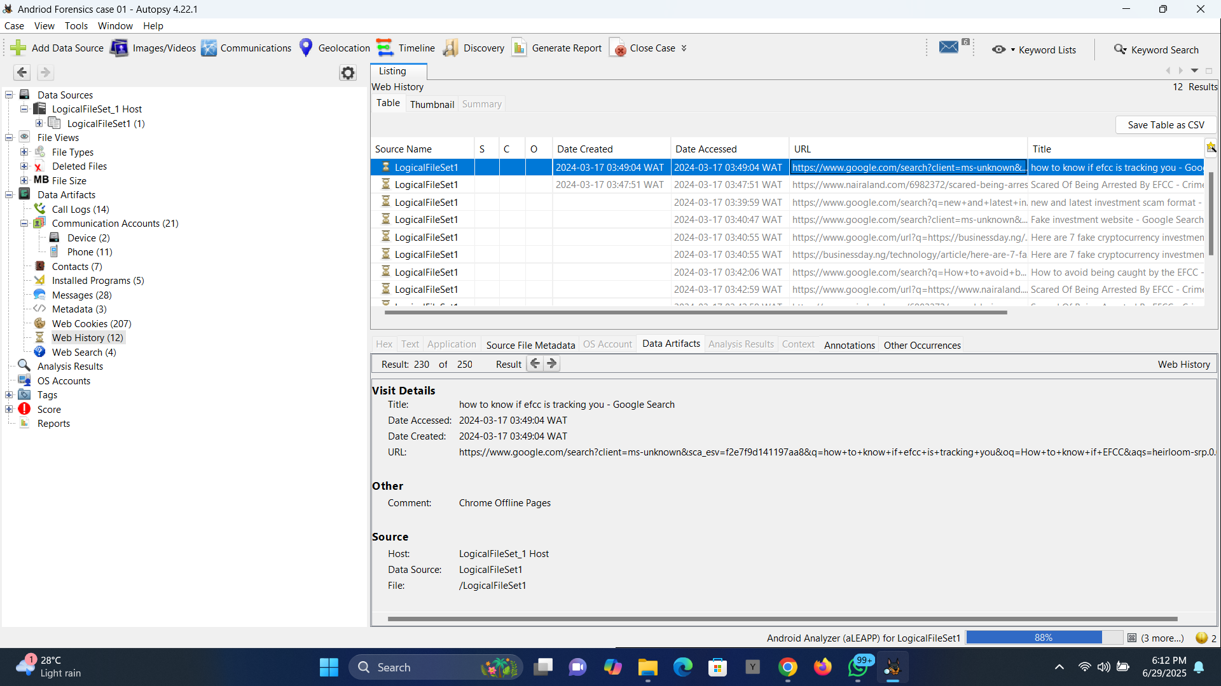

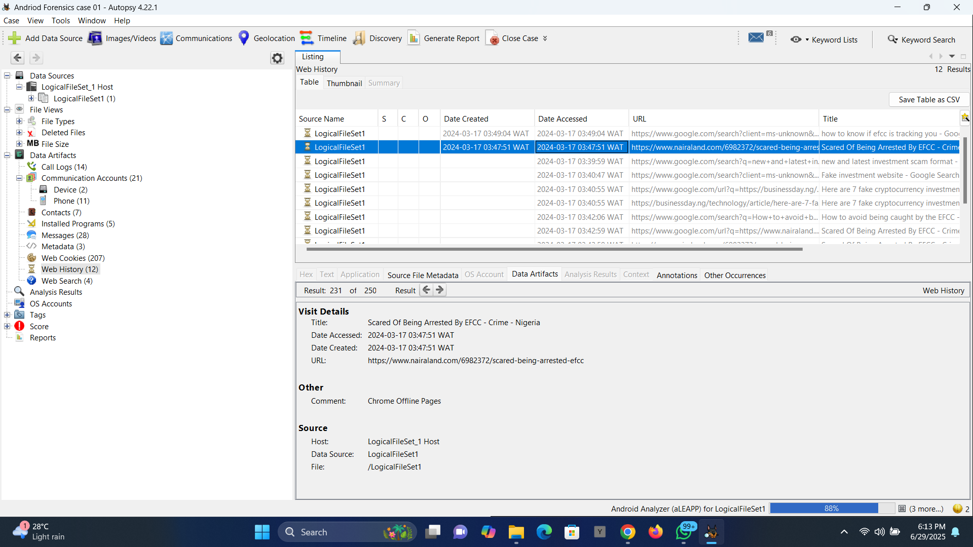

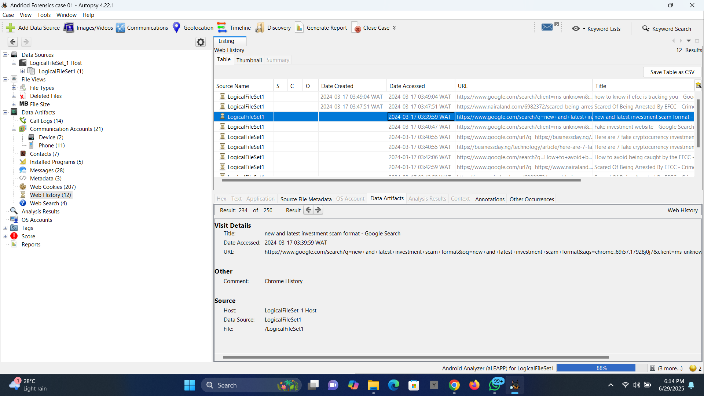

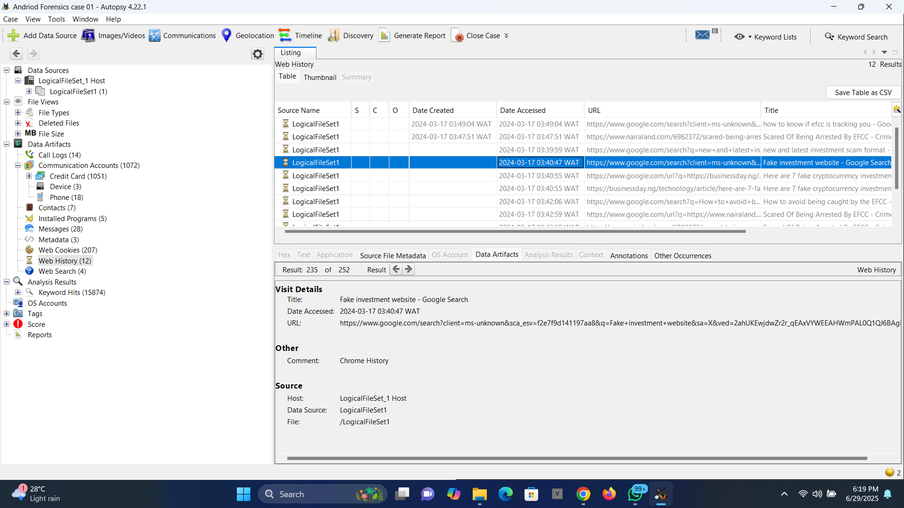

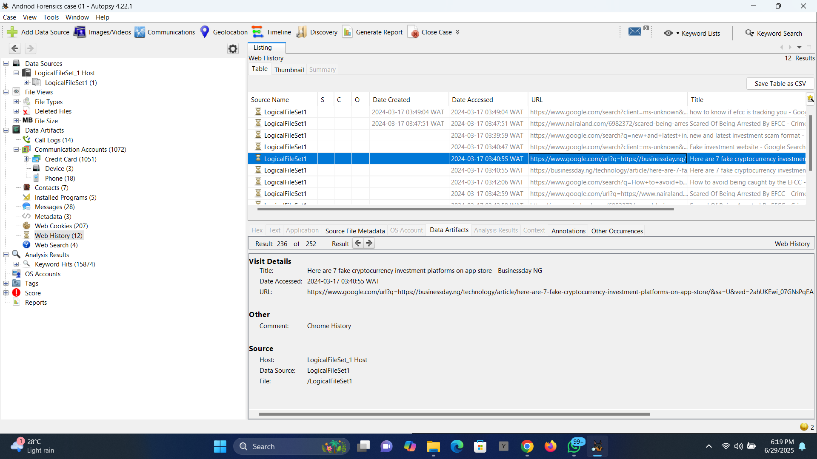

Images showing the suspect's browsing history on how to evade EFFC and looking up fake investment platforms

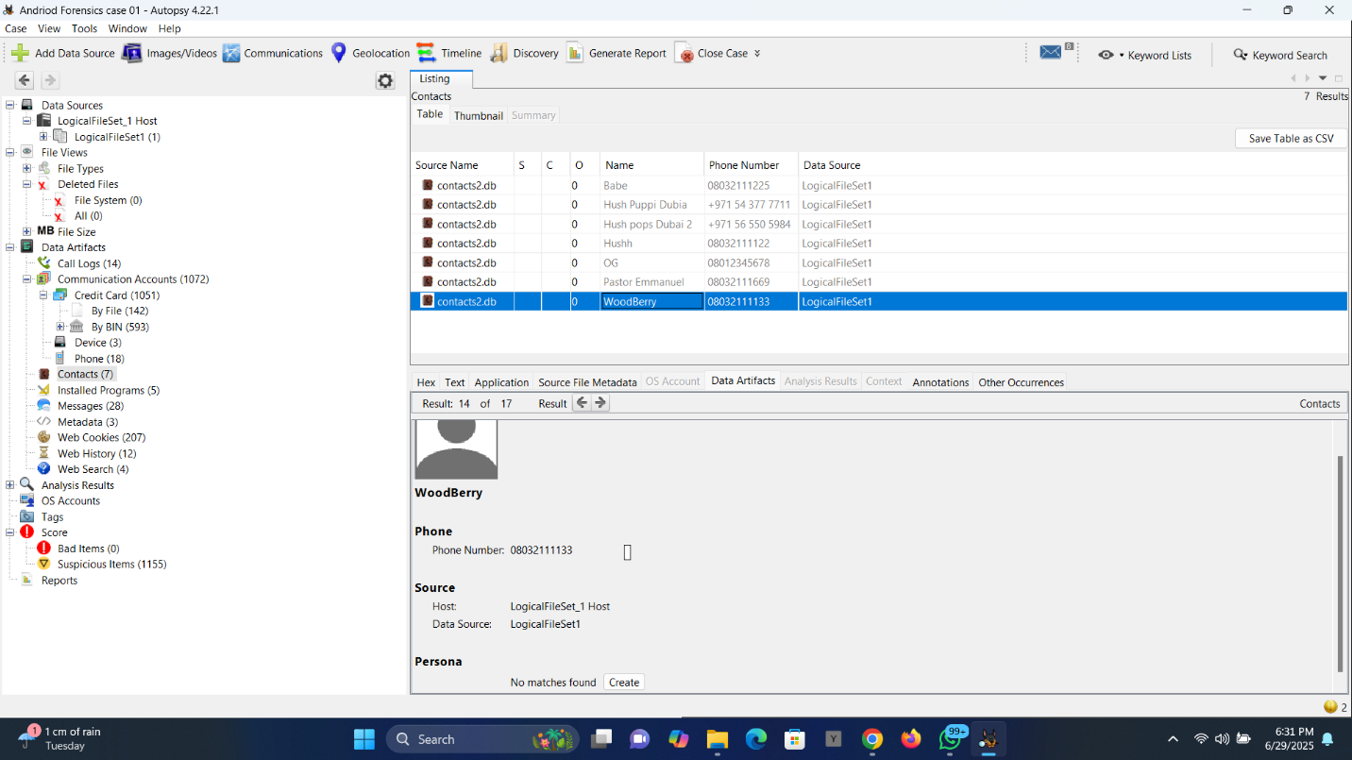

The contact info of the first individual the suspect had a scam conversation with, named WoodBerry.

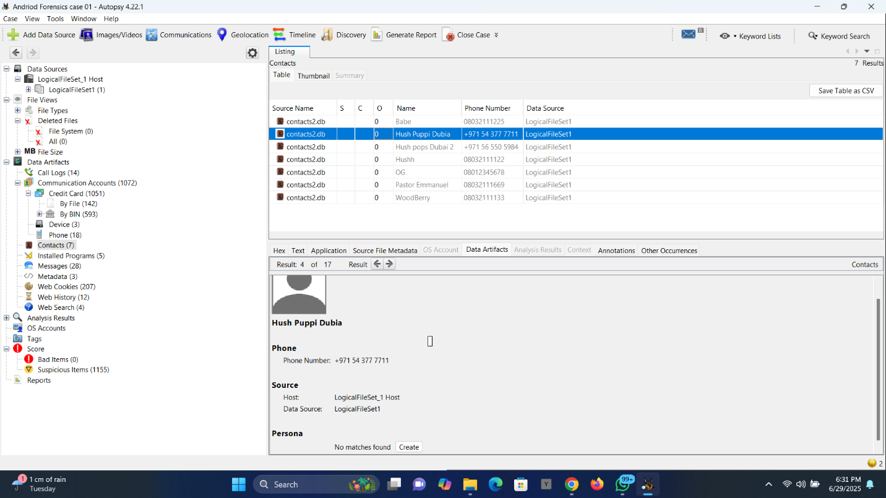

The second individual the suspect had conversations with was named Hush Puppi.

**PROJECT PART III**

**Virtual Firewall Implementation using OPNsense**

**Objective:**

To enhance the lab environment with a virtual firewall for traffic inspection and segmentation using OPNsense. The goal was to route traffic between virtual machines (Kali Linux and Windows 10) through the firewall and apply filtering rules to simulate enterprise-grade network segmentation.

**Environment Setup**

* Firewall OPNsense: 25.1 (amd64)
* Hypervisor: Oracle VirtualBox
* LAN Interface: 192.168.1.1/24 (em0)
* Kali Linux: 192.168.1.100
* Windows 10: 192.168.1.101

Each virtual machine was connected to the LAN through an internal network, with Kali’s gateway and Windows’ gateway both set to 192.168.1.1 (OPNsense LAN IP).

**Configuration Steps**

**1. Setting Up the Virtual Firewall**

* I downloaded the OPNsense 25.1 ISO file, set it up as a VM in VirtualBox, and installed it onto a virtual disk using the UFS partition scheme.
* During installation, I assigned two virtual adapters:
  + - * em0 for LAN (internal network with Kali and Windows)
      * em1 for WAN (not used actively but needed for setup)
* After setup, I accessed the firewall via its web interface at https://192.168.1.1 from Kali Linux Firefox browser

**2. Configuring the Network**

* I configured Kali Linux with IP: 192.168.1.100, Gateway: 192.168.1.1
* I configured Windows 10 with IP: 192.168.1.101, Gateway: 192.168.1.1
* All systems were attached to the same internal network, ensuring all traffic between them passed through OPNsense.
* I enabled Promiscuous Mode in VirtualBox for proper packet flow visibility.

**3. Creating a Firewall Rule**

The task was to block ping (ICMP) traffic from Kali to Windows, simulating a restriction commonly found in secured networks.

Before creating the rule, I made sure all three machines were up and running (Kali, Windows and OPNsense), to ensure proper flow of traffic. And then, making sure the two VMs (Kali and Windows) were both connected to OPNsense and using it as the default gateway, I ran these commands:

1. ip route on Kali, which confirmed using OPNsense as the default gateway
2. ipconfig on Windows, which also gave the same confirmation
3. Here’s how I created the rule in OPNsense:
   * + Navigated to: Firewall > Rules > LAN
     + Added a Block rule:
       - Protocol: ICMP
       - Source: 192.168.1.100 (Kali)
       - Destination: 192.168.1.101 (Windows)
       - Description: Block Kali from pinging Windows
4. I moved this rule to the top to give it the highest priority.
5. Saved and applied the changes.

**Verification**

To confirm that the rule was working, I opened the terminal on Kali and ran:

ping 192.168.1.101

Result:

Instead of receiving reply packets, the output showed:

From 192.168.1.100 icmp_seq=1 Destination Host Unreachable

...

100% packet loss

This meant the rule successfully blocked ICMP traffic, preventing Kali from pinging Windows.

**Screenshots of Important Steps**

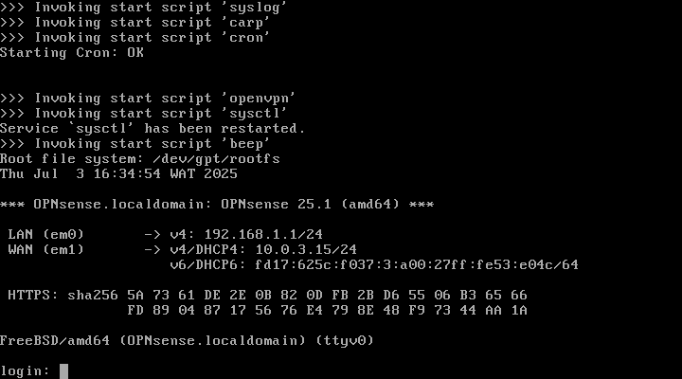

OPNsense installation done on Oracle Virtualbox

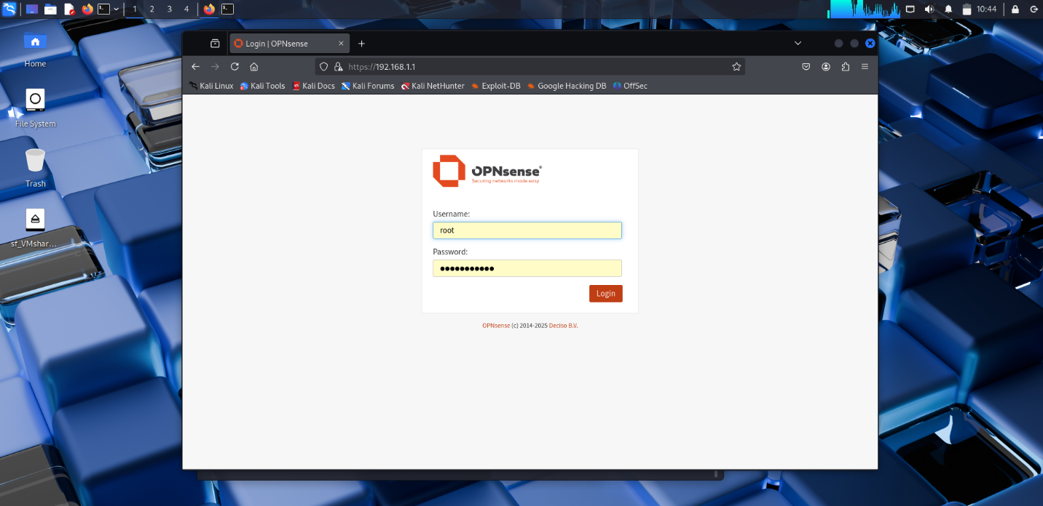

OPNsense webGUI login from Kali Firefox

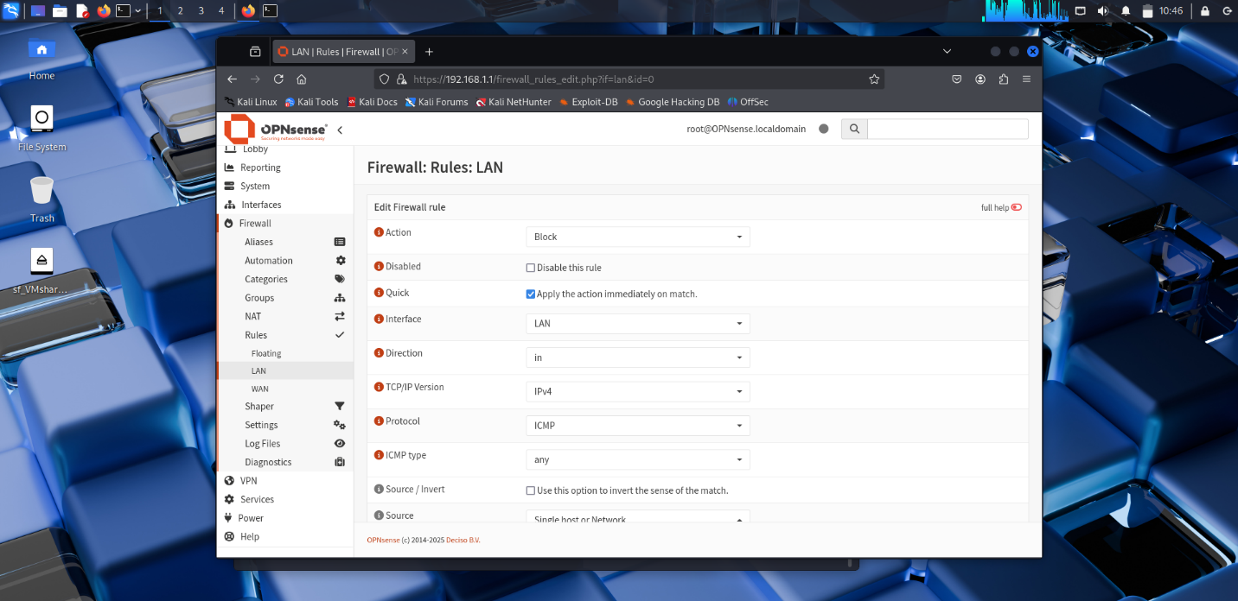

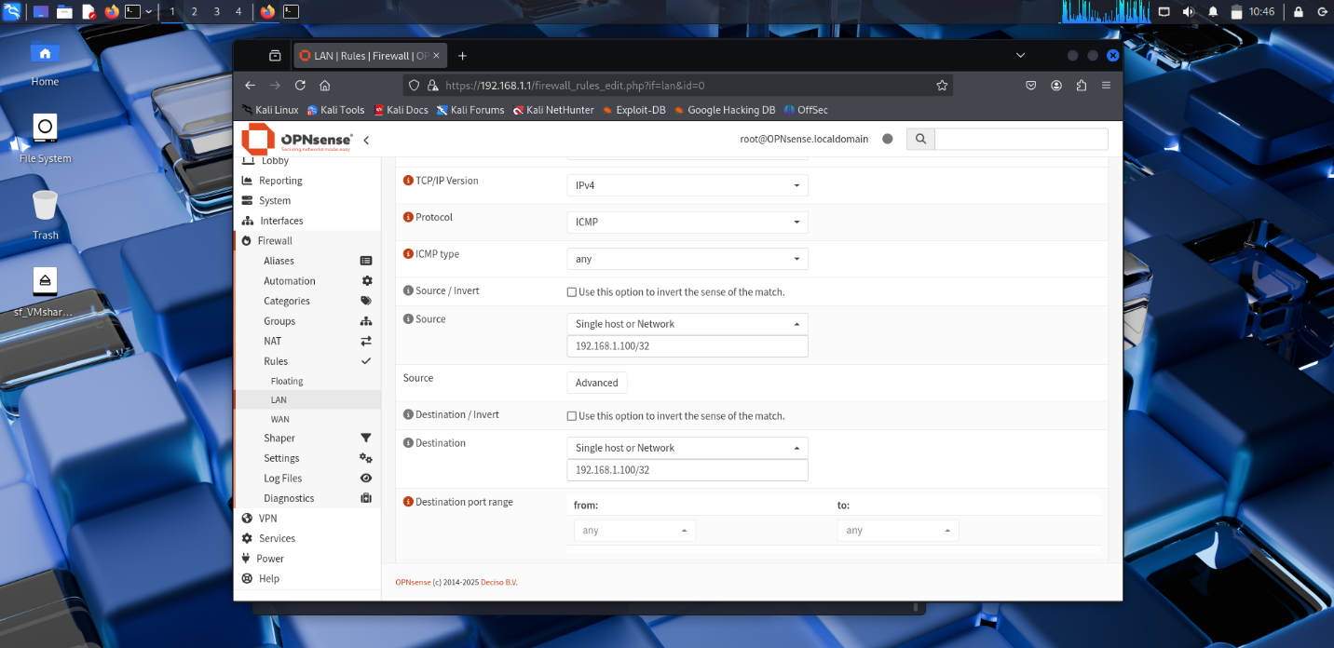

Applying rule configuration to enable Windows Block Ping from Kali

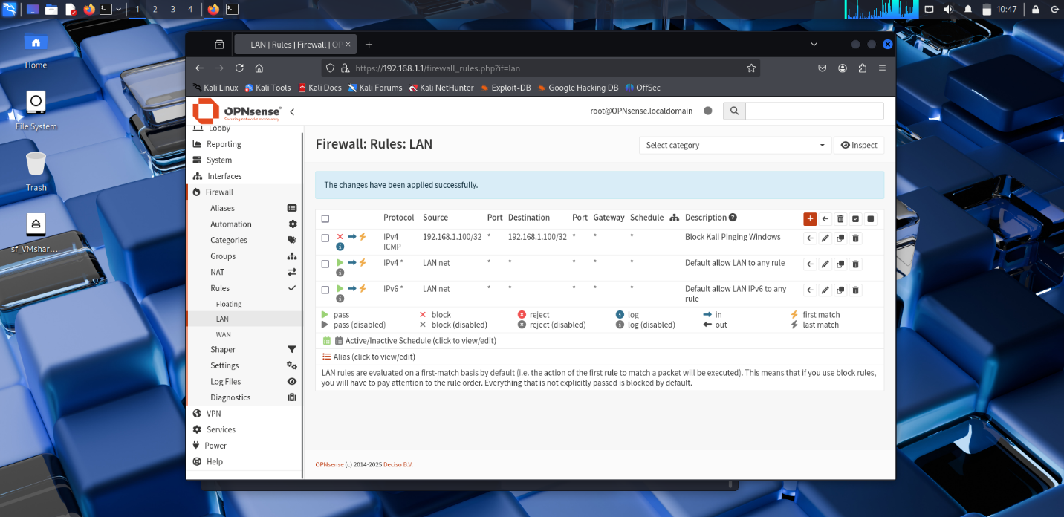

Saving the rule configuration and making sure the rule is at the top

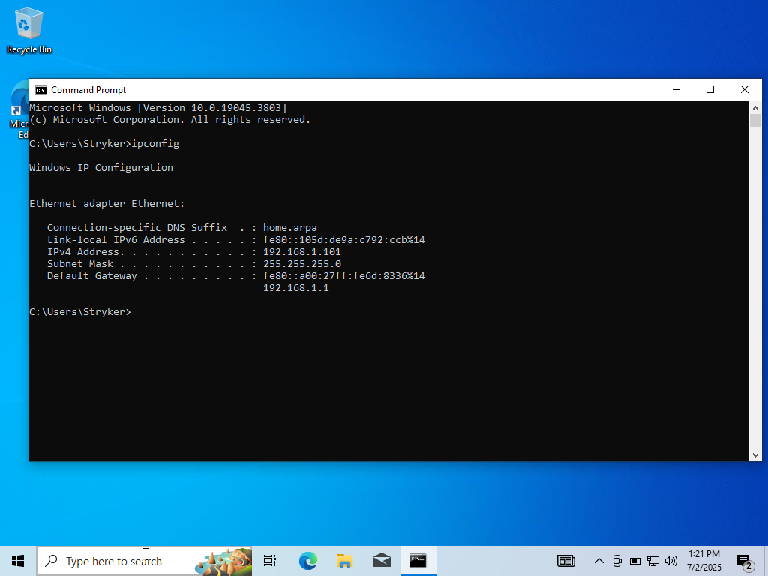

Confirming Windows IP and default gateway

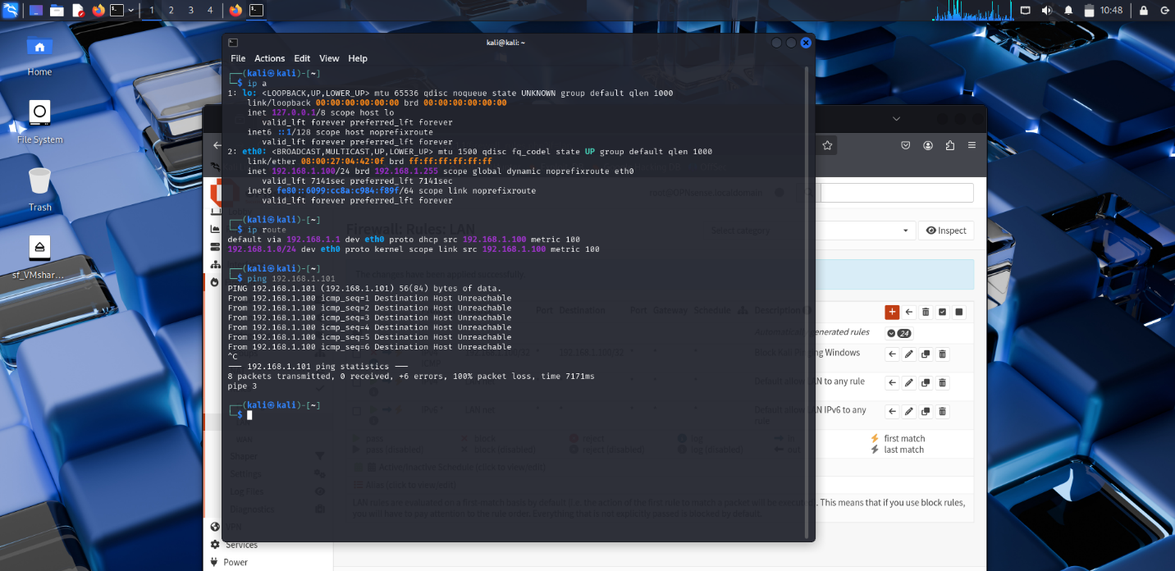

Confirming Kali’s IP and default gateway, and also confirming the success of the rule that was set up